NatHERS Trade Mark Guidelines
Version 5.1

© Commonwealth of Australia 2026
Ownership of intellectual property rights
Unless otherwise noted, copyright (and any other intellectual property rights) in this publication is owned by the Commonwealth of Australia (referred to as the Commonwealth).
Creative Commons licence
All material in this publication is licensed under a Creative Commons Attribution 4.0 International Licence except content supplied by third parties, logos and the Commonwealth Coat of Arms.
Inquiries about the licence and any use of this document should be submitted via our online contact form.

Disclaimer
The Australian Government acting through the Department of Climate Change, Energy, the Environment and Water has exercised due care and skill in preparing and compiling the information and data in this publication. Notwithstanding, the Department of Climate Change, Energy, the Environment and Water, its employees and advisers disclaim all liability, including liability for negligence and for any loss, damage, injury, expense or cost incurred by any person as a result of accessing, using or relying on any of the information or data in this publication to the maximum extent permitted by law.
Acknowledgement of Country
We acknowledge the Traditional Owners of Country throughout Australia and recognise their continuing connection to land, waters and culture. We pay our respects to their Elders past and present.
Change log
Version | Date | Amendment | Supersedes
1.0 | June 2017 | ‘Guidelines for using the NatHERS logo’ revised | Previous version
2.0 | May 2022 | Revised and updated Trade Mark Guidelines | Version 1.0
2.1 | July 2022 | Department name amended | Version 2.0
3.0 | Oct 2023 | Whole of Home trade mark guidelines added and 6.5 star logo replaced with 7 star logo. | Version 2.1
4.0 | July 2025 | Addition of NatHERS for existing homes to the Trade Mark Guidelines | Version 3.0
5.0 | June 2026 | Added trade marks 2610969 and 2610970 for Home Energy Ratings.  Clarified eligibility to use trade marks including a new summary table, a section for entities engaged in home energy ratings disclosure, and a section for state and territory governments.  Added and clarified conditions for using trade marks and representation of trade marks.  Added information on cobranding.  Expanded indicative examples of disclaimers. | Version 4.0
5.1 | July 2026 | Added trade marks 2610971 and 2610973 for Home Energy Ratings.  Added trade marks 2610974 and 261975 for NatHERS and Nationwide House Energy Rating Scheme coverage under class 35 (advertising) for disclosure purposes. | Version 5.0

Contents
NatHERS Trade Mark Guidelines 1
Introduction 4
Eligibility to use trade marks 5
Seeking authorisation to use Trade Marks 9
Cobranding 10
Conditions for using Trade Marks 10
Unauthorised use of Trade Marks 11
Representation of Trade Marks 11
Contact 13
Appendices 14
Appendix A: Trade Mark images 14
Appendix B: Cobranding example 15
Appendix C: Indicative examples of disclaimers 15

Introduction
  - The NatHERS Trade Mark Guidelines (Guidelines) outline the permitted uses of registered trade marks, or trade marks proceeding through registration processes, associated with the Nationwide House Energy Rating Scheme (Scheme).
  - There are presently 12 Scheme trade marks registered or being registered under the Trade Marks Act 1995 (Cth) for the Scheme, which are owned by the Commonwealth, or for which action has been taken to assert ownership:
- trade mark 1486221: NatHERS logo image (see Appendix A)
- trade mark 1646672: Scheme name ‘Nationwide House Energy Rating Scheme’
- trade mark 1646673 and 2610975: Scheme acronym ‘NatHERS’
- trade mark 1646674: thermal rating image (see Appendix A)
- trade mark 2335780: rating name ‘Whole of Home’
- trade mark 2335781: Whole of Home rating image (see Appendix A)
- trade mark 2610969: Scheme name ‘Home Energy Rating accredited by NatHERS’
- trade mark 2610970: Home Energy Rating logo image (see Appendix A)
- trade mark 2610971: Combined star rating and Home Energy Rating images (see Appendix A) – being registered
- trade mark 2610973: Home Energy Rating image (see Appendix A) – being registered
Trade Marks
  - Additional Home Energy Rating trade marks are in the process of being registered, and these Guidelines will be updated from time to time.
  - For the purposes of these Guidelines, Trade Marks refers to already registered trade marks and to trade marks proceeding through registration processes.
  - The Home Energy Rating brand has been developed to support expansion of the Scheme to existing homes. It is endorsed by all state and territory governments. The brand also acts as an entry point for households to learn about home energy ratings in general.
  - The Home Energy Rating Trade Marks are primarily being used in relation to products for existing homes ratings and to communicate ratings to households.
  - The NatHERS Trade Marks continue to be used to identify ratings of new homes, including the use of those ratings to demonstrate compliance with building standards for new homes and renovations. They are also used when referring to Scheme administration, governance and accreditation activities.
  - The purpose of registration of the Trade Marks is, among other things, to protect the credibility of the Scheme.
  - NatHERS is administered by the Department of Climate Change, Energy, the Environment and Water (the NatHERS Administrator) on behalf of all state and territory governments. The NatHERS Administrator reserves the right to act in response to infringement of the Trade Marks (see section 6 of these Guidelines).
  - These Guidelines support the Scheme’s governance. Other documents relating to the Scheme’s governance include:
- relating to Home Energy Rating (NatHERS) for new homes, the:
  - NatHERS Software Accreditation Protocol and its Terms and Conditions
  - NatHERS Protocol for Assessor Accrediting Organisations
  - NatHERS for new homes Technical Note
  - NatHERS Compliance and Enforcement Framework
  - Demonstrating integrity as a NatHERS for new homes assessor.
- relating to Home Energy Rating for existing homes, the:
  - NatHERS User Interface Protocol for existing homes and its Terms and Conditions
  - NatHERS Assessor Code of Practice for existing homes
  - NatHERS Technical Note for existing homes for existing homes.
- relating to the overall Scheme, the NatHERS Complaint Management Policy.
  - The Australian Trade Mark Register provides detail on classes of goods and services of the trade marks registered to the Scheme at www.ipaustralia.gov.au/trade-marks.

Eligibility to use trade marks
  - Table 1 summarises eligibility to use Trade Marks by specific users, and who to ask for permission when that is required. Refer to clauses 2.2 through 2.9 for further details on eligibility and conditions for each user group.
  - If your organisation is not part of the user groups listed in Table 1, you can still request approval from the NatHERS Administrator (see clause 3.3).

Table 1 – what Trade Marks can I use, and who do I ask for permission when that is required?
IMPORTANT: this table is provided for summary purposes only. Please read this Guideline in full to be sure you understand your eligibility and conditions for using Trade Marks, including but not limited to details for specific user categories (clauses 2.3 – 2.11) and the process for requesting digital assets (clause 7.3).
User category | NatHERS logo  (TM 1486221) | Nationwide House Energy Rating Scheme  (TM 1646672) | NatHERS acronym  (TM 1646673 and  TM 261075) | Thermal rating image  (TM 1646674) | Whole of Home name  (TM 2335780) | Whole of Home rating image  (TM 2335781) | Home Energy Rating accredited by NatHERS  (TM 2610969) | Home Energy Rating logo  (TM 2610970) | Combined star rating and Home Energy Rating images (TM 2610971) | Home Energy Rating image (TM 2610973)
State and territory governments | Yes | Yes | Yes | Yes | Yes | Yes | Yes | Yes | Yes | Yes
Accredited Software Tool Providers and CSIRO | Yes | Yes | Yes | Yes | Yes | Yes | Yes | Yes | Yes | Yes
Registered Training Organisations | Yes | Yes | Yes | Yes | Yes | Yes | Yes | Yes | Yes | Yes
Assessor Accrediting Organisations (AAOs) | Yes | Yes | Yes | Yes | Yes | Yes | Yes | Yes | No | No
Accredited Home Energy Rating (NatHERS) assessors for new homes | Ask  your  AAO | Ask  your  AAO | Ask  your  AAO | Ask  your  AAO | Ask  your  AAO | Ask  your  AAO | Ask  your  AAO | Ask  your  AAO | No | No
Assessor Accreditation Service Providers (AASPs) | Yes | Yes | Yes | No | No | No | Yes | Yes | Yes | Yes
Accredited Home Energy Rating assessors for existing homes | Ask  your  AASP | Ask  your  AASP | Ask  your  AASP | No | No | No | Ask  your  AASP | Ask  your  AASP | Ask  your  AASP | Ask  your  AASP
Entities engaged in home energy ratings disclosure (e.g. real estate professionals) | No | Ask the NatHERS Administrator | Ask the NatHERS Administrator | No | No | No | Ask the  NatHERS Administrator | Ask the NatHERS Administrator | Ask the NatHERS Administrator | Ask the NatHERS Administrator
Non-accredited Home Energy Rating (NatHERS) assessors for new homes (raters) | No | Yes | Yes | No | Yes | No | No | No | No | No

  - State and territory governments are permitted to use all Trade Marks for the purposes of communications about energy efficiency and performance, including promotional materials and websites, in accordance with the conditions set out in these Guidelines. States and territories liaise with the NatHERS Administrator on Trade Mark use through the NatHERS Steering Committee.
  - Providers of software tools accredited with the NatHERS Administrator under the Software Accreditation Protocol (NatHERS for new homes) or the User Interface Protocol (NatHERS for existing homes), as well as the Commonwealth Scientific and Industrial Research Organisation (CSIRO), are permitted to use all Trade Marks in relation to software tools and user interfaces approved by the NatHERS Administrator. Use of Trade Marks must be in accordance with the conditions set out in these Guidelines. This extends to the following use of Trade Marks on Home Energy Rating (NatHERS) Certificates for new homes and Home Energy Rating Certificates for existing homes:
    - Certificates produced by accredited assessors may include all NatHERS trade marks.
    - Certificates produced for new homes by non-accredited assessors (raters) may include only the name ‘Nationwide House Energy Rating Scheme’ (TM 1646672), the name ‘Whole of Home’ (TM 2335780) and the acronym ‘NatHERS’ (TM 1646673).
  - Registered training organisations (RTOs) that deliver qualifications or training required to become, and continue to be, an accredited assessor for Home Energy Rating for existing homes or Home Energy Rating (NatHERS) for new homes are permitted to use all Trade Marks on the condition that the Home Energy Rating logo (TM 2610970) and the NatHERS logo (TM 1486221) cannot be used on student or trainer qualification documents.
Approval for RTOs to use these Trade Marks is limited to inclusion in promotional materials, training materials and websites, in accordance with the conditions set out in these Guidelines.
  - Assessor Accrediting Organisations (AAOs) approved by the NatHERS Administrator to accredit NatHERS for new homes assessors under the Protocol for Assessor Accrediting Organisations are permitted to use the following Trade Marks:
- NatHERS logo image (TM 1486221)
- Scheme name ‘Nationwide House Energy Rating Scheme’ (TM 1646672)
- Scheme acronym ‘NatHERS’ (TM 1646673 and TM 2610975)
- Thermal rating image (TM 1646674)
- Rating name ‘Whole of Home’ (TM 2335780)
- Whole of Home rating image (TM 2335781)
- The name ‘Home Energy Rating accredited by NatHERS’ (TM 2610969)
- Home Energy Rating logo image (TM 2610970)
Approval for AAOs to use these Trade Marks is limited to inclusion in promotional materials and websites, in accordance with the conditions set out in these Guidelines.
  - Accredited assessors for new homes can use the following Trade Marks in accordance with these Guidelines and subject to written authorisation to use the relevant Trade Mark from their AAO:
- NatHERS logo image (TM 1486221)
- Scheme name ‘Nationwide House Energy Rating Scheme’ (TM 1646672)
- Scheme acronym ‘NatHERS’ (TM 1646673 and TM 2610975)
- Thermal rating image (TM 1646674)
- Rating name ‘Whole of Home’ (TM 2335780)
- Whole of Home rating image (TM 2335781)
- The name ‘Home Energy Rating accredited by NatHERS’ (TM 2610969)
- Home Energy Rating logo image (TM 2610970)
Approval for accredited assessors for new homes to use these Trade Marks is limited to inclusion in promotional materials directly related to the preparation of Home Energy Rating (NatHERS) assessments for new homes including websites, advertisements, business cards and letterhead.
  - Assessor Accreditation Service Providers (AASPs) who are contracted by the NatHERS Administrator to accredit NatHERS for existing homes assessors are permitted to use the following Trade Marks:
- NatHERS logo image (TM 1486221)
- Scheme name ‘Nationwide House Energy Rating Scheme’ (TM 1646672)
- Scheme acronym ‘NatHERS’ (TM 1646673 and TM 2610975)
- The name ‘Home Energy Rating accredited by NatHERS’ (TM 2610969)
- Home Energy Rating logo image (TM 2610970)
- Combined star rating and Home Energy Rating images (TM 2610971)
- Home Energy Rating image (TM 2610973)
Approval for AASPs to use these Trade Marks is limited to inclusion in promotional materials and websites, in accordance with the conditions set out in these Guidelines.
  - Accredited assessors for existing homes can use the following Trade Marks in accordance with these Guidelines and subject to written authorisation to use the relevant Trade Mark from their AASP:
- NatHERS logo image (TM 1486221)
- Scheme name ‘Nationwide House Energy Rating Scheme’ (TM 1646672)
- Scheme acronym ‘NatHERS’ (TM 1646673 and TM 2610975)
- The name ‘Home Energy Rating accredited by NatHERS’ (TM 2610969)
- Home Energy Rating logo image (TM 2610970)
- Combined star rating and Home Energy Rating images (TM 2610971)
- Home Energy Rating image (TM 2610973)
Approval for Accredited assessors for existing homes to use these Trade Marks is limited to inclusion in promotional materials directly related to the preparation of Home Energy Rating assessments for existing homes including websites, advertisements, business cards and letterhead.
  - Entities engaged in home energy ratings disclosure (Disclosure Partners), such as banks and other financial institutions as well as real estate professionals, may seek permission from the NatHERS Administrator to use the following Trade Marks:
- The name ‘Home Energy Rating accredited by NatHERS’ (TM 2610969)
- Home Energy Rating logo image (TM 2610970)
- Scheme name ‘Nationwide House Energy Rating Scheme’ (TM 1646672)
- Scheme acronym ‘NatHERS’ (TM 1646673 and TM 2610975)
- Combined star rating and Home Energy Rating images (TM 2610971)
- Home Energy Rating image (TM 2610973)
Approval for Disclosure Partners to use these Trade Marks is limited to inclusion in promotional materials and websites related to the use of Home Energy Ratings, to rate and disclose home energy performance, in accordance with the conditions set out in these Guidelines.
  - Non-accredited assessors (raters) may seek permission to use the following Trade Marks in accordance with these Guidelines and solely in relation to preparing NatHERS ratings for new homes:
- Scheme name ‘Nationwide House Energy Rating Scheme’ (TM 1646672)
- Scheme acronym ‘NatHERS’ (TM 1646673 and TM 2610975)
- Rating name ‘Whole of Home’ (TM 2335780)
Non-accredited assessors (raters) are not permitted to use the logos (TM 1486221 or TM 2610970), rating images (TM 1646674, TM 2335781, TM 2610971 or TM 2610973) or ‘Home Energy Rating accredited by NatHERS’ (TM 2610969) for any purpose.

Seeking authorisation to use Trade Marks
  - The following organisations have been granted authority by the NatHERS Administrator to approve use of Trade Marks by assessors they accredit for the Scheme:
- Australian Building Sustainability Accreditation by the Building Designers Association of Australia, www.bdaa.com.au
- Design Matters National, www.designmatters.org.au
- House Energy Raters Association, hera.asn.au
  - State and territory governments, AAOs, AASPs, CSIRO, software tool providers and RTOs do not need to request prior written authorisation from the NatHERS Administrator to use Trade Marks in accordance with these Guidelines. The NatHERS Administrator should be notified prior to the release of reports, fact sheets, presentations or similar publications or communications that contain Trade Marks.
  - Disclosure Partners and all other individuals or entities seeking to use Trade Marks must obtain prior written authorisation from the NatHERS Administrator. Those seeking permission from the NatHERS Administrator must complete the Trade Mark Approval Form and submit this with relevant supporting materials by email to admin@nathers.gov.au.
  - Those seeking permission from the NatHERS Administrator (or, for an accredited assessor, their AAO or AASP) must comply with any conditions imposed as part of giving consent to use a Trade Mark.

Cobranding
  - The cobranded Home Energy Rating and NatHERS logos in Appendix B can be used by accredited assessors and organisations engaged in delivery of ratings for both existing and new homes, subject to clauses 3.1-3.4 and the conditions set out in these Guidelines.
  - Cobranded logos featuring both Home Energy Rating and the National Australian Built Environment Rating System (NABERS) are being developed to support home energy ratings disclosure. Please email admin@nathers.gov.au if you wish to discuss intended uses of cobranded Home Energy Rating / NABERS logos prior to submitting a Trade Mark Approval Form.
  - Only the NatHERS Administrator can agree to co-brand using our Trade Marks. Those wishing to discuss the creation of cobranding with our Trade Marks must state this on their Trade Mark Approval Form.
  - Those with prior approval to use Trade Marks do not need to apply for approval to use Home Energy Rating and NatHERS logos alongside their business branding, subject to any conditions imposed as part of giving consent to use a Trade Mark including those set out in these Guidelines.

Conditions for using Trade Marks
The following conditions apply to all uses of Trade Marks.
  - Trade Marks must only be used for the specified and authorised purposes as detailed in the request (if any) and as set out within these Guidelines.
  - All Trade Mark use must comply with the requirements outlined in Representation of trade marks (clauses 7.1-7.4).
  - Trade Marks must not mislead members of the public into believing the product, service or entity involved has any government sponsorship, affiliation or certification. A prominent disclaimer must be included when using Scheme logos (TM 1486221 or TM 2610970) or rating images (TM 1646674 or TM 2335781). The disclaimer must:
- state the relationship to NatHERS (for example, offering NatHERS assessments, offering training courses in NatHERS approved software tools)
- clarify the organisation, services and/or website does not have any government sponsorship, affiliation or certification
- link to official information regarding Home Energy Ratings and NatHERS (www.homeenergyrating.gov.au).
Example disclaimers are provided in Appendix C.
  - Trade Marks must not be used in association with a product, service or entity that conflicts, or could potentially conflict, with the objective of NatHERS to promote improvements to the energy efficiency and performance of dwellings.
  - Use of Trade Marks must not risk bringing the Home Energy rating and NatHERS logos, the Scheme, the Commonwealth, or another government body, into disrepute or reduce their credibility.
  - Trade Marks are not to be used for marketing and promotion of specific housing developments and properties. Those wishing to promote the energy rating of their development or property are encouraged to follow the approach in the Home Energy Ratings Disclosure Framework, including publishing the Home Energy Rating or NatHERS certificates.
  - Trade Marks must not be used on any merchandise and apparel, other than clothing to be worn by persons providing products and services directly related to the Scheme, without express permission from the NatHERS Administrator.
  - Subject to clause 3.2, use of Trade Marks for inclusion in a report, fact sheet, presentation or similar publication or communications must be provided to, and authorised by, the NatHERS Administrator prior to publication.

Unauthorised use of Trade Marks
  - Use of any Trade Marks other than in accordance with the requirements of this Guideline or any authorisation provided under it (Unauthorised Use), is prohibited. Appropriate action may be taken against entities who undertake Unauthorised Use of the Trade Mark/s.
  - Prior authorisation may be withdrawn and/or appropriate legal action may be taken against entities who undertake Unauthorised Use of the Trade Mark/s who, in the opinion of the NatHERS Administrator, have used the Trade Mark/s in a manner that has reduced its credibility or otherwise breached these Guidelines.
  - The NatHERS Administrator retains the right to deny or withdraw authorisation of Trade Mark use, including where authorisation has been granted by an approving body or use of the Trade Marks is otherwise permitted by these Guidelines.

Representation of Trade Marks
  - All use of Trade Marks must follow the style guidelines below to ensure the integrity of their application.
  - Scheme names and acronym (TM 1646672, TM 1646673 and TM 2610969) and Whole of Home rating name (TM 2335780):
- Capitalise each word in ‘Nationwide House Energy Rating Scheme’.
- The name Nationwide House Energy Rating Scheme should be referenced in full at first mention, before using the acronym ‘NatHERS’ thereafter.
- Use lowercase ‘at’ in the acronym NatHERS.
- lower case ‘of’ in the name Whole of Home.
- Capitalise each word in the name ‘Home Energy Rating’.
- Always refer to Home Energy Rating in full. No abbreviation or acronym is acceptable.
  - Logo and rating images (TM 1486221, TM 1646674, TM 2335781 and TM 2610970):
- Supplied logos and images must be used as provided. They must not be altered or tampered with. This includes:
  - modification, distortion, recolouring, or rotation of a logo/image
  - application of effects to a logo/image
  - attaching/including additional or altered text in a logo/image.
  - The NatHERS logo and rating images are for use on a white background only.
- The Home Energy Rating logo is available in a range of colours so it can be used on various backgrounds. The NatHERS Administrator can advise on colour options included in the brand colour palette.
- White and black versions of the NatHERS and Home Energy Rating logos are available on request. These should only be used in limited circumstances (e.g. when colour printing is unavailable or when no other colour option provides adequate contrast). When selecting colours ensure that logos or text maintain legibility. Follow the WCAG 2.0 accessibility guide as reference.
- Logos should not be copied from the NatHERS website or elsewhere. Digital design files should be obtained from:
  - For accredited Assessors, your AAO or AASP.
  - For all others, the NatHERS Administrator.
- Ensure logos maintain prominence and legibility a clear space and minimum size.
  - Clear space:
    - No less than 30% of logo width (7mm at minimum logo size) of clear space on all sides, set around the NatHERS logo or rating images.
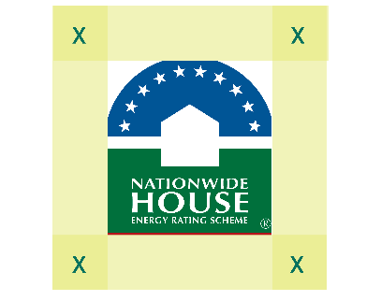
    - No less than 30% of logo width (6.3mm at minimum logo size) clear space on all sides, set around the Home Energy Rating logo.
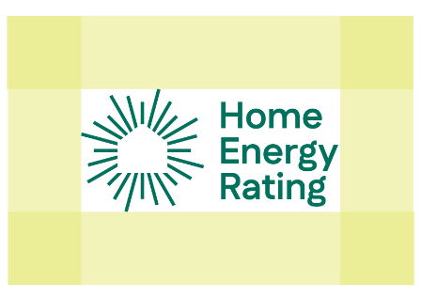
    - The above clear space measurement applies to all versions of the logos.
  - Minimum size:
    - Width should be no less than 21mm for the NatHERS logo.
    - Width should be no less than 19mm wide for the inline Home Energy Rating logo.
  - For the use of the Rating images (TM 1646674 and TM 2335781) as part of NatHERS Certificates or Home Energy Rating Certificates, the following aspects of the image must be as generated by a NatHERS-accredited software tool or CSIRO’s AccuRate Enterprise software tool as part of a NatHERS Certificate or Home Energy Rating Certificate. The following may vary from what is shown in the registered NatHERS trade mark images:
- The star rating number and associated graphic.
- The predicted annual energy load for heating.
- The Whole of Home performance rating number and associated graphic.

Contact
If you have any questions regarding authorised use of Trade Marks, contact the NatHERS Administrator via email admin@nathers.gov.au.
Alternatively, post correspondence to:
Nationwide House Energy Rating Scheme
Department of Climate Change, Energy, the Environment and Water
GPO Box 3090
CANBERRA ACT 2601

Appendices

Appendix A: Trade Mark images
For reference only. If you are approved to use these Trade Marks contact the NatHERS Administrator (or, if you are an accredited assessor, your AAO or AASP) to obtain digital design files.
Home Energy Rating logo image TM 2610970
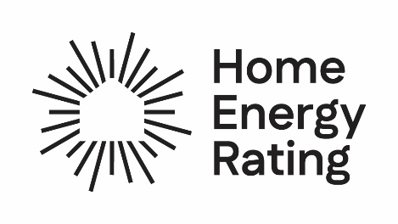

Combined star rating and Home Energy Rating images (TM 2610971)
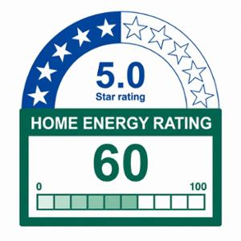

Home Energy Rating image (TM 2610973)
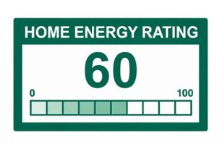

NatHERS logo image TM 1486221
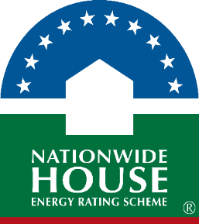

Thermal rating image TM 1646674
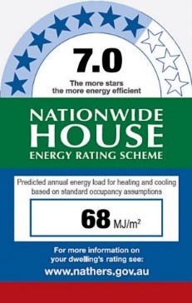

Whole of Home rating image TM 2335781
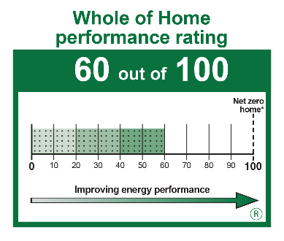

Appendix B: Cobranding example
The below cobrand lock up can be used by accredited assessors and organisations engaged in delivery of ratings for both existing and new homes (as per clauses 4.1 and 4.4). Accredited assessors should contact their AAO or AASP for digital design files. Others wishing to cobrand must contact the NatHERS Administrator.

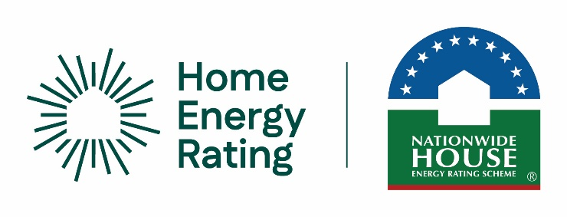

Appendix C: Indicative examples of disclaimers
For reference only. Users of Trade Marks are responsible for ensuring their disclaimer meets requirements set out in these Guidelines.
For a Disclosure Partner such as banks and other financial institutions and real estate professionals:
‘Permission to use the Home Energy Rating and Nationwide House Energy Rating Scheme (NatHERS) trade marks has been granted to <organisation> for the purpose of supporting disclosure of Home Energy Ratings. <Organisation> and its services has no direct affiliation with NatHERS. More information on Home Energy Ratings at www.homeenergyrating.gov.au’.
For an assessor accredited to provide Home Energy Ratings for existing homes
‘Permission to use the Home Energy Rating and Nationwide House Energy Rating Scheme (NatHERS) trade marks has been granted to <organisation> for the purpose of offering Home Energy Rating assessments for existing homes. <Organisation> and its services has no direct affiliation with NatHERS. More information on Home Energy Ratings at www.homeenergyrating.gov.au’.
For an assessor accredited to provide Home Energy Ratings (NatHERS) for new homes
‘Permission to use the Home Energy Rating and Nationwide House Energy Rating Scheme (NatHERS) trade marks has been granted to <organisation> for the purpose of offering Home Energy Rating (NatHERS) assessments for new homes. <Organisation> and its services has no direct affiliation with NatHERS. More information on Home Energy Ratings at www.homeenergyrating.gov.au’.
For an assessor accredited to provide assessments for both existing and new homes:
‘Permission to use the Home Energy Rating and Nationwide House Energy Rating Scheme (NatHERS) trade marks has been granted to <organisation> for the purpose of offering Home Energy Rating assessments for existing homes and Home Energy Rating (NatHERS) ratings for new homes. <Organisation> and its services has no direct affiliation with NatHERS. More information on Home Energy Ratings at www.homeenergyrating.gov.au’.

