



Home Energy Rating – Software Protocol for New and Existing Homes

Appendices

Consultation draft 6 November 2026


© Commonwealth of Australia 2026
Ownership of intellectual property rights
Unless otherwise noted, copyright (and any other intellectual property rights) in this publication is owned by the Commonwealth of Australia (referred to as the Commonwealth).
Creative Commons licence
All material in this publication is licensed under a Creative Commons Attribution 4.0 International Licence except content supplied by third parties, logos and the Commonwealth Coat of Arms.
Inquiries about the licence and any use of this document should be emailed to copyright@dcceew.gov.au.

Cataloguing data
This publication (and any material sourced from it) should be attributed as: DCCEEW 2026, Home Energy Rating Software Protocol for new and existing homes, Department of Climate Change, Energy, the Environment and Water, Canberra, CC BY 4.0.
This publication is available at Homeenergyrating.gov.au
Department of Climate Change, Energy, the Environment and Water
GPO Box 3090 Canberra ACT 2601
Telephone 1800 920 528
Web Homeenergyrating.gov.au
Disclaimer
The Australian Government acting through the Department of Climate Change, Energy, the Environment and Water has exercised due care and skill in preparing and compiling the information and data in this publication. Notwithstanding, the Department of Climate Change, Energy, the Environment and Water, its employees and advisers disclaim all liability, including liability for negligence and for any loss, damage, injury, expense or cost incurred by any person as a result of accessing, using or relying on any of the information or data in this publication to the maximum extent permitted by law.
Acknowledgement of Country
We acknowledge the Traditional Owners of Country throughout Australia and recognise their continuing connection to land, waters and culture. We pay our respects to their Elders past and present.

Change log
Version | Summary
20261030 | EEWG notification
20261106 | Consultation draft

Contents
Purpose 1
Document structure 1
Obligations terminology 1
1. Appendix: Accreditation readiness and testing requirements 2
Part A — Purpose and application 2
1.1. Purpose, scope and application 2
Part B — Functional requirements 2
1.2. General functional outcomes 2
1.3. Workflow and role controls 2
1.4. Assessment data capture, sources and validation status 3
1.5. Automated and assisted functionality 3
1.6. Dwelling model creation and editing 4
1.7. Model and assessment data integrity 5
1.8. Certificate generation controls 5
1.9. Records, traceability and audit 5
1.10. Third-party products, services and integrations 6
Part C — Accreditation-readiness testing and evidence 6
1.11. Representative assessments 6
1.12. Dwelling and assessment scenario coverage 6
1.13. Requirements testing and traceability 7
1.14. Readiness evidence 7
1.15. Additional testing and verification 8
2. Appendix: Accreditation submission checklists 9
3. Appendix: Benchmark dwellings and scenarios 10
4. Appendix: Accreditation rating accuracy tolerances 21
5. Appendix: CSIRO software updates – SOP 23
6. Appendix: General Update form 30
7. Appendix: General update review procedures 32
8. Appendix: Minimum software training requirements for new and existing homes 34
8.1. Purpose 34
8.2. Training scope and resource requirements 34

List of tables
Table 1: NatHERS reference climate zones 15
Table 2: Benchmark new homes testing scenarios for appliance and system settings (UNDER REVIEW) 17
Table 3: Benchmark existing homes testing scenarios for appliance and system settings 19
Table 4: Thermal rating accuracy tolerances 21
Table 5: Home energy rating accuracy tolerances 22
Table 6: General change indicative checks 32

List of figures
Figure 1: New homes benchmark dwelling designs 10
Figure 2: Existing home benchmark dwelling designs 14

Purpose
This document supports the Home Energy Rating Software Protocol by setting out the detailed technical specifications, testing parameters, evidence requirements, forms, procedures and supporting requirements used in software development and accreditation, ongoing compliance and software updates. It is intended to be read in conjunction with the Software Protocol and applies to software for new and existing homes, as relevant.

Document structure
Accreditation readiness
- Accreditation readiness and testing requirements: Defines the representative assessments, testing, and evidence software providers must complete before applying for accreditation.
- Accreditation and reaccreditation submission checklists: Lists the software access, benchmark assessments, agreements, supporting material, and privacy and security evidence to be submitted for accreditation or reaccreditation.
Accuracy
- Benchmark dwellings and scenarios: Defines the representative dwellings, climate zones and assessment scenarios used to test software performance for new and existing homes.
- Rating accuracy tolerances: Specifies the allowable differences between software results and benchmark results for thermal ratings, energy use, costs and Home Energy Ratings.
Software updates
- CSIRO software updates SOP: Outlines the process and impacts associated with implementing CSIRO software updates.
- General Update form: Provides a standard form for software providers to describe and submit proposed software changes, their impacts, supporting evidence and implementation arrangements.
- General update review procedures: Provides an indicative, risk-based guide to the evidence and checks that may apply when the NatHERS Administrator assesses different types of software updates.
Training
- Minimum software training requirements for new and existing homes: Specifies the software-specific training and guidance resources providers must maintain to support competent, compliant use by assessors and data collectors.

Obligations terminology
Shall: identifies a mandatory requirement
Should: a recommended control or capability but is not strictly required.
May: the action is completely optional or left to the software provider’s discretion.

Appendix: Accreditation readiness and testing requirements

Part A — Purpose and application

Purpose, scope and application
This appendix sets out the activities, testing and evidence that software providers shall complete before submitting software for accreditation. It applies to new homes and existing homes software, as relevant to the proposed scope of accreditation.
The requirements supplement the applicable CSIRO API schema and all other applicable NatHERS requirements. They apply regardless of the software’s user interface, workflow, system architecture or data structure.
The requirements (sections 1.2 to 1.10) are outcome-based and do not prescribe a particular technology, vendor, device, data-capture method, modelling approach or artificial intelligence technique. Software may use conditional logic to present only those inputs, evidence requirements and workflow controls relevant to an assessment, provided this does not remove, conceal or prevent compliance with any applicable requirement.
Testing (sections 1.11 to 1.15) shall demonstrate that the software is sufficiently mature and functional to proceed to formal accreditation assessment and field testing. Completion of the activities in this appendix does not constitute accreditation or limit the NatHERS Administrator’s ability to request additional information, evidence, demonstrations or testing.
The omission of a specific input, evidence type, software function or workflow requirement from this appendix does not remove any obligation imposed by another applicable NatHERS requirement.

Part B — Functional requirements

General functional outcomes
Software shall:
- support the functions required for the applicable assessment type
- produce assessment information that is fit-for-purpose, reviewable, editable and auditable
- support user verification and, where permitted, correction, rejection or override of assessment information before it is relied upon, including identification of unreliable information and items requiring validation, in accordance with sections below
- preserve user corrections and assessment record integrity in accordance with section 1.7 and
- support review, monitoring, investigation and audit through the records and traceability required by section 1.9.

Workflow and role controls
Where a data collector contributes to an assessment, software shall:
- only allow an accredited assessor to generate an accredited certificate
- enable the data collector to collect and submit assessment information
- record the data collector’s identity and contributions, where required and
- enable the accredited assessor to review, correct, reject and approve information for which the assessor is responsible.
Software may permit simulations before all requirements for an accredited certificate have been satisfied, provided that simulations and preliminary outputs are clearly distinguished from accredited assessment outputs.

Assessment data capture, sources and validation status
Software should support import or extraction from plans, specifications, schedules, photographs, certificates, previous assessments and other relevant evidence. Captured information may include dimensions, room and zone classifications, construction types, glazing, appliances, roof and shading characteristics.
For each material assessment value, software shall:
- record its source, and where applicable, the method by which it was derived
- identify material assumptions, required user validation and validation status and
- distinguish approved defaults from other values.
Users shall validate estimated, inferred, derived, calculated or automatically generated information.
For existing homes assessments, software shall allow the assessor to record areas or elements that could not be accessed or visually inspected, including the reason, the default or assumption applied, and any supporting evidence or justification.

Automated and assisted functionality
Where automated or assisted functionality is used, software shall:
- enable accredited assessors and accredited data collectors to accept, reject, modify or override automated inputs and outputs
- identify information that could not be determined reliably by automated functionality
- present tool generated information in a user-friendly format for review
- retain sufficient information to support audit, monitoring and investigation.
Where automated or assisted functionality fails, is unavailable or cannot produce information reliably, software shall not present the resulting information as verified assessment information and shall provide an appropriate alternative manual or user-review pathway.
Software should record confidence or reliability indicators for automatically generated or extracted information and use those indicators to prioritise user review.

Dwelling model creation and editing

Dwelling representation and generation
The software shall:
- support manual creation, editing and completion of dwelling geometry including the correct representation of a floorplan
- generate dwelling geometry from available information and allow dimensions, orientation, geometry and layouts to be corrected
- accommodate drawing-based, scan-based and hybrid workflows as appropriate across relevant residential building types
The software should:
- offer three-dimensional visualisation where it improves validation or assessment efficiency.

Geometry, zoning and building elements
The software shall:
- allow rooms and zones to be created, modified, merged, split, renamed and deleted
- record and allow modification of dwelling orientation, floor-to-ceiling heights, and the orientation of external walls and glazing
- record connections between adjoining zones, including permanent openings and vertical connections;
- allow relevant building elements and geometric features to be added, modified and classified, including:
  - windows, doors and permanent openings
  - floor levels, stairs and vertical connections
  - raked and complex ceilings, bulkheads and local ceiling-height variations
  - open-plan zones, ancillary spaces and adjacencies and
  - glazing, roof characteristics and shading;
- allow relevant attributes to be recorded and modified at dwelling, zone and element level; and
- allow users to correct or override generated geometry, attributes and building elements where required.

Evidence management and assessment documentation
Software shall support the upload, storage, retrieval and management of evidence (e.g. graphics, documents, notes) required by the NatHERS Technical Note.
For new homes assessments, software shall support storage of the design documentation used to support the assessment.
Software shall:
- associate evidence with the relevant assessment, dwelling, zone, element, opening, feature, service, system, input, assumption or modelling decision
- support multiple evidence records against one assessment item where required
- retain the relationship between evidence and information generated or derived from it
- make evidence retrievable for review and audit
- retain the metadata of uploaded evidence
- only require evidence where required by applicable NatHERS documentation.
- Include assessor notes

Model and assessment data integrity
As the dwelling representation or assessment information is edited, software shall:
- maintain relationships between rooms, zones, openings and building elements
- preserve user-entered attributes unless the user confirms a change
- preserve zone connectivity and validated corrections
- identify changes that may affect geometry, zoning, element placement or assessment results.
Software should retain links between supporting evidence and derived information, identify inconsistencies introduced by later edits and assist the user to resolve them.
Validation should identify disconnected zones, incomplete geometry, inconsistent dimensions, duplicate or overlapping geometry, and potentially incorrect classifications or extracted values. Software should distinguish other validation outcomes as warnings or informational items.

Certificate generation controls
Software shall only allow an accredited assessor to generate an accredited certificate.
Before generating an accredited certificate, software shall require an accredited assessor to complete all mandatory declarations, consents and workflow confirmations specified in the Software Protocol.
Software shall prevent generation of an accredited certificate where a mandatory declaration, consent, workflow confirmation or blocking validation issue remains unresolved.

Records, traceability and audit
Software shall retain sufficient information for authorised users to:
- review assessment inputs, outputs and changes
- identify sources, assumptions, defaults, estimates, imported values, generated values and calculations
- locate supporting evidence and associated approvals or justifications
- review dwelling modelling, geometry and zoning decisions
- identify user changes, corrections, rejections and overrides
- identify the contributing user or role where required
- reproduce assessment outcomes where required
- audit the assessment record after completion.
Where information is overridden, software shall retain sufficient information to identify the original value or outcome, the replacement value or outcome, and the user or role responsible for the override.
Where information is obtained using automated or assisted technologies, software shall retain the source, capture or derivation method, generated or extracted values, corrections, overrides and user validation undertaken.

Third-party products, services and integrations
Where software relies on a third-party product, service, device, dataset or integration to satisfy an applicable requirement, the software provider shall ensure that the resulting functionality continues to satisfy that requirement and shall maintain sufficient information to support testing, monitoring and audit. The use of a third-party product, service, device, dataset or integration does not remove the software provider’s responsibility for compliance with applicable Software Protocol requirements.

Part C — Accreditation-readiness testing and evidence

Representative assessments
Before applying for accreditation, the software provider shall complete representative assessments comprising two categories: benchmark assessments and field assessments.
Benchmark assessments using the benchmark dwelling files and testing scenarios specified by NatHERS, to demonstrate compliance with applicable accreditation and rating accuracy requirements.
Field assessments conducted under representative real-world conditions, to demonstrate that the software supports practical, repeatable, efficient and compliant assessment workflows.
For software seeking accreditation for existing homes, field assessments shall demonstrate the data collector and accredited assessor workflow specified in section 3.

Dwelling and assessment scenario coverage
The representative assessments shall be tested across a range of dwelling forms, configurations, features and workflows to demonstrate that it performs appropriately across its proposed accreditation scope.
Testing should include, where relevant to the proposed accreditation scope, the following dwelling characteristics and assessment scenarios:

Building fabric, forms and layouts
- building fabric
- single-storey, multi-storey and split-level dwellings
- detached, attached and multi-residential dwellings, including apartments
- open-plan areas, multiple thermal zones, attached garages, conditioned and unconditioned spaces
- enclosed balconies, sunrooms and similar transitional spaces.

Complex geometry and construction
- double-height voids and mezzanine spaces
- staircases and intermediate landings
- curved walls and non-orthogonal (angled) wall geometry
- bulkheads and other complex ceiling features
- complex roof and ceiling forms, including raked and cathedral ceilings
- mixed construction types
- atypical or complex floor plans requiring advanced modelling techniques.

Openings and shading
- mixed glazing types, clerestory windows, skylights and roof windows
- shading, airtightness and infiltration information
- horizontal and vertical shading, neighbouring buildings and other complex shading arrangements.

Services and systems
- multiple heating and cooling systems
- hot water, lighting, cooking, pools and spas
- solar photovoltaic systems and batteries.

Requirements testing and traceability
Software shall test each applicable requirement and maintain a requirements traceability record identifying:
- the requirement tested
- the test case, scenario or assessment used
- the expected and actual results
- the supporting evidence -
each assessment file prepared for accreditation-readiness activities shall identify:
- the assessment date in YYYYMMDD format
- the software name and version
- a unique assessment identifier
- the applicable CSIRO platform or API version, where relevant
- the assessment type and test scenario
- the test outcome and any identified limitation or defect and
- any corrective action and retesting undertaken.

Readiness evidence
The software provider shall submit a statement confirming that sufficient testing has been undertaken to test and demonstrate compliance with the accreditation-readiness activities.
The software provider shall retain and submit, when requested, sufficient evidence to demonstrate completion of the accreditation-readiness activities. Evidence may include:
- completed assessment files, outputs and supporting evidence
- test plans, test cases, expected results and actual results
- benchmark and scenario testing results
- workflow demonstrations, screenshots, recordings and system exports
- automated or assisted functionality testing records and known limitations
- training, guidance and supporting resources
- third-party product, service or integration information
- other evidence reasonably requested by the NatHERS Administrator.

Additional testing and verification
The NatHERS team may require additional dwelling types, scenarios, test cases, demonstrations, supporting evidence or independent verification where needed to assess functionality, workflow, accuracy, repeatability, traceability or alignment with the proposed accreditation scope.
The NatHERS team may require clarification, correction, retesting or resubmission where reasonably necessary to determine whether the software is ready to proceed to accreditation.

Appendix: Accreditation submission checklists
Software providers should consult the NatHERS team to confirm the applicable submission requirements. The checklist below is indicative, and additional or alternative information may be requested.
Item
Software
Access to UI beta version
Access to fourth party data collection technologies
Inputs & workflows
NatHERS User Interface Input Checklist for existing homes
Accuracy
Existing homes benchmark files
Assessment file dwelling 101
Assessment file dwelling 401 x 12 Whole of Home scenarios, including evidence
Assessment file dwelling 501 x 12 Whole of Home scenarios
Assessment file dwelling 611
Assessment file dwelling 612
New homes benchmark files
Assessment file dwelling 110
Assessment file dwelling 100
Assessment file dwelling 200 TBV
Assessment file dwelling 200 StMC
Assessment file dwelling 200 StLC
Assessment file dwelling 200 StBV
Assessment file dwelling 400
Assessment file dwelling 500
Assessment file dwelling 610
Assessment file dwelling 620
Assessment file dwelling 630
Optimisations
Description and analysis of rating impacts
Training & guidance
Training material
Outputs
Ratings summaries and dashboard displays
Security, privacy and access control
Audit logging requirements
Authentication requirements
Authorisation requirements
Backup requirements
Data hosting requirements
Data disposal requirements
Documentation requirements
Encryption key management requirements
Encryption at rest requirements
Encryption in transit requirements
Export function requirements
Input validation requirements
Personnel security requirements
Security monitoring requirements

Appendix: Benchmark dwellings and scenarios
Benchmark dwellings and scenarios have been developed by the NatHERS team in consultation with stakeholders.
Detailed specifications including drawings are available by contacting UIP@nathers.gov.au.
More benchmark plans are used for new homes because they include thermal bridging scenarios that do not apply to existing homes. Existing homes software is also tested onsite using real homes, reducing the need for additional benchmark dwellings. This onsite testing is captured in the Software Protocol as “observed operation in representative environments”.
Figure 1: New homes benchmark dwelling designs
Dwelling | Plan | Benchmark testing scenarios
Dwelling | Plan | Thermal star rating | Home Energy Rating
100  4-bedroom single level brick veneer construction | 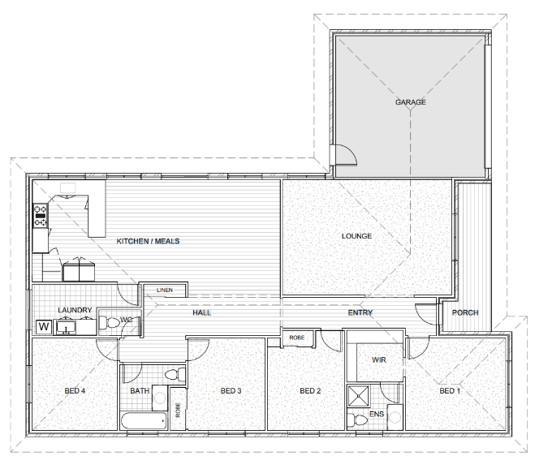 | 69 NatHERS Climate Zones | N/A
200 TBV  4-bedroom, two level  Timber frame brick veneer | Ground floor  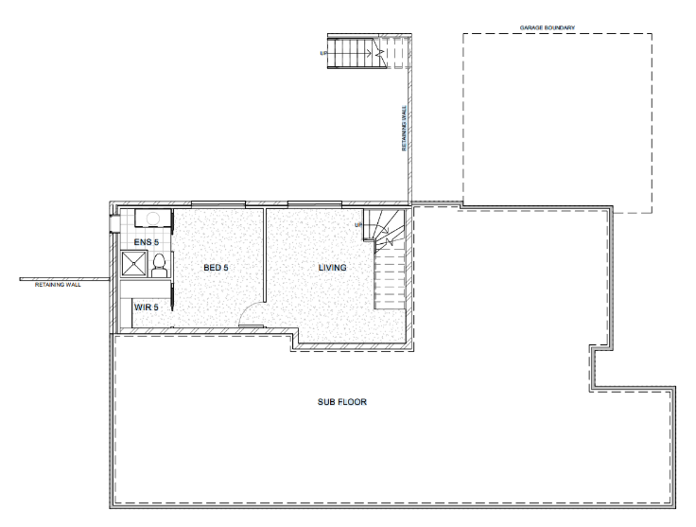  Top floor  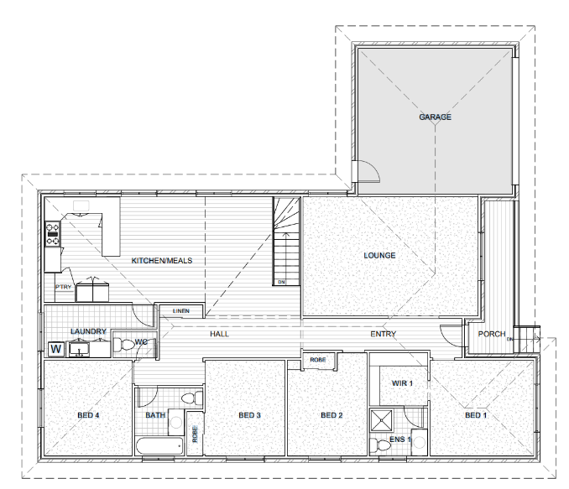 | 69 NatHERS Climate Zones | 11 representative climate zones Table 1  Scenarios at Table 2
200 StBV  4-bedroom, two level  Steel frame brick veneer | Ground floor  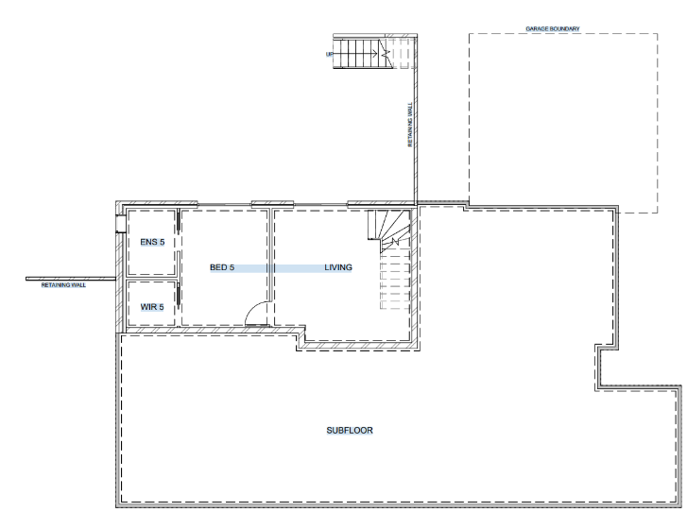  Top floor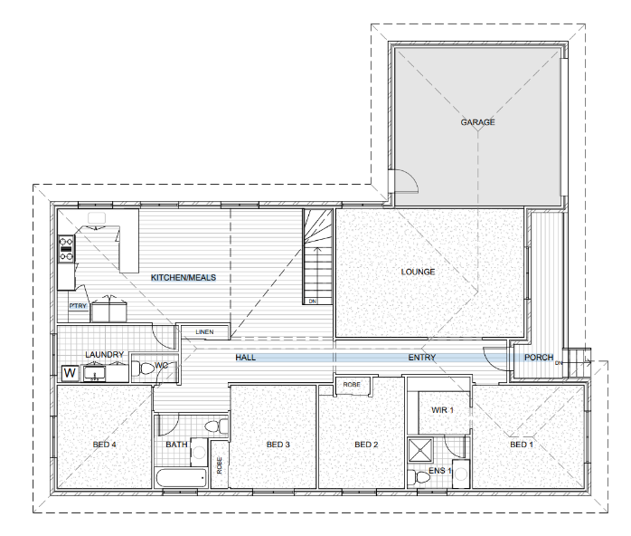 | 69 NatHERS Climate Zones | N/A
200 StLC  4-bedroom, two level  Steel frame light cladding | Ground floor  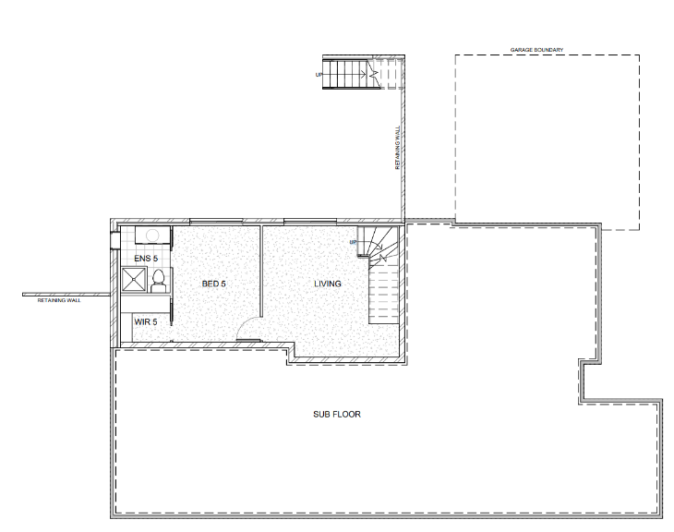  Top floor  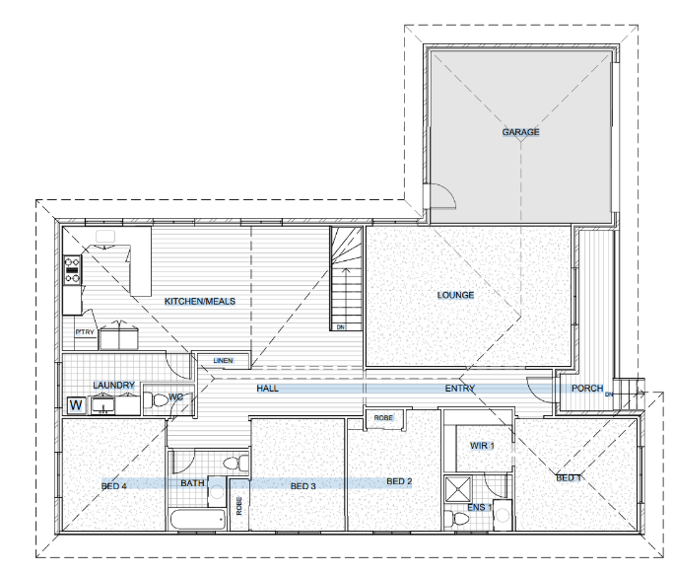 | 69 NatHERS Climate Zones | N/A
200 StMC  4-bedroom, two level  Steel frame metal cladding | Ground floor  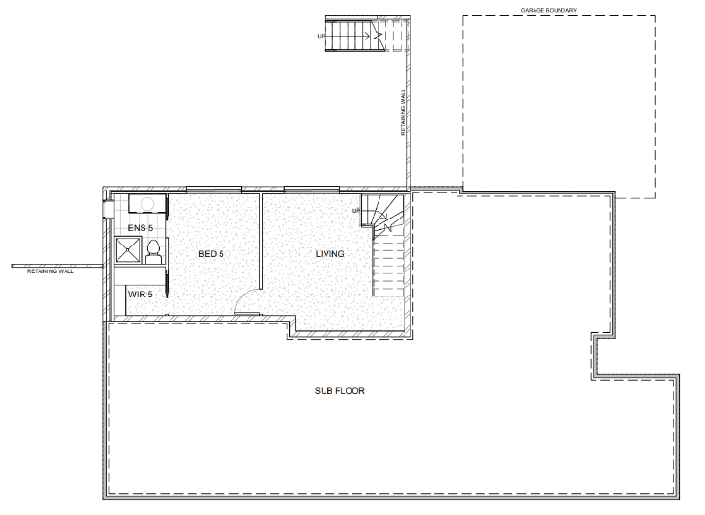  Top floor  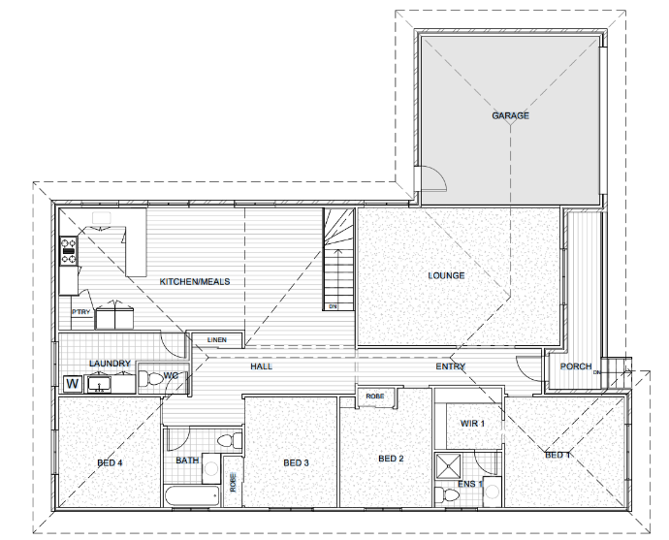 | 69 NatHERS Climate Zones | N/A
300  3-bedroom, single level | 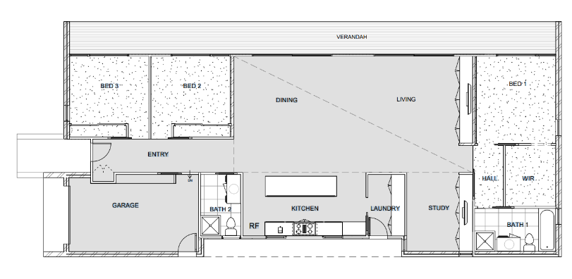 | 69 NatHERS Climate Zones | N/A
400  3-bedroom, two level  Timber frame, hardwood cladding | 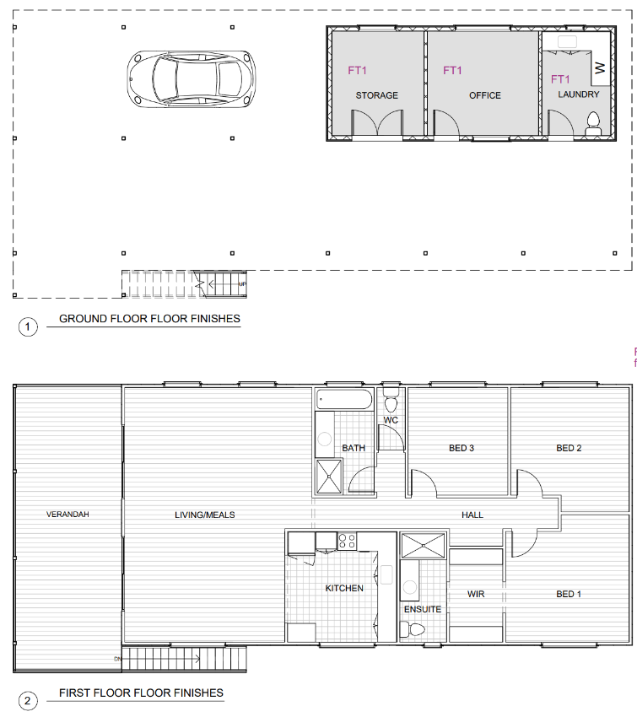 | 69 NatHERS Climate Zones | N/A
500  4-bedroom, two level  Timber frame, pressed brick | 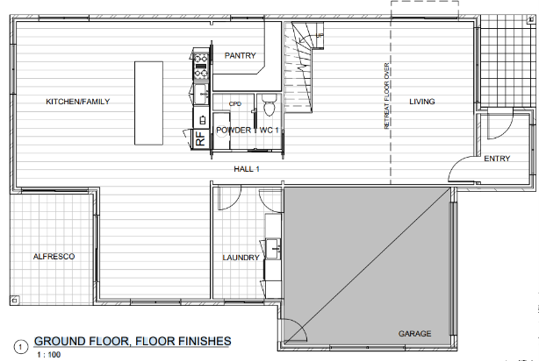  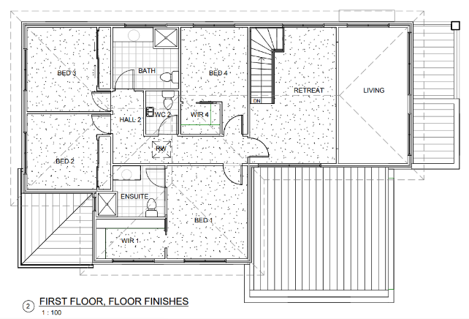 | 69 NatHERS Climate Zones | 11 representative climate zones Table 1  Scenarios at Table 2
610  1-bedroom, ground floor apartment | 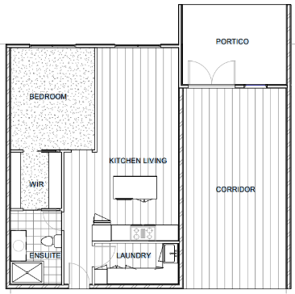 | 69 NatHERS Climate Zones | N/A
620  2-bedroom, fifth floor apartment | 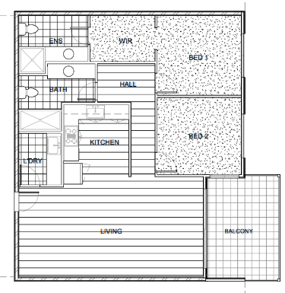 | 69 NatHERS Climate Zones | N/A
630  2-bedroom, top floor apartment | 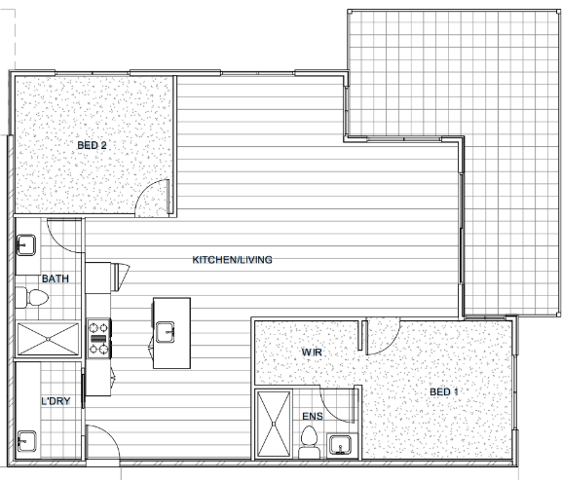 | 69 NatHERS Climate Zones | N/A

Figure 2: Existing home benchmark dwelling designs
Dwelling | Plan | Benchmark testing scenarios
Dwelling | Plan | Thermal star rating | Home Energy Rating
101  4-bedroom single level brick veneer construction | 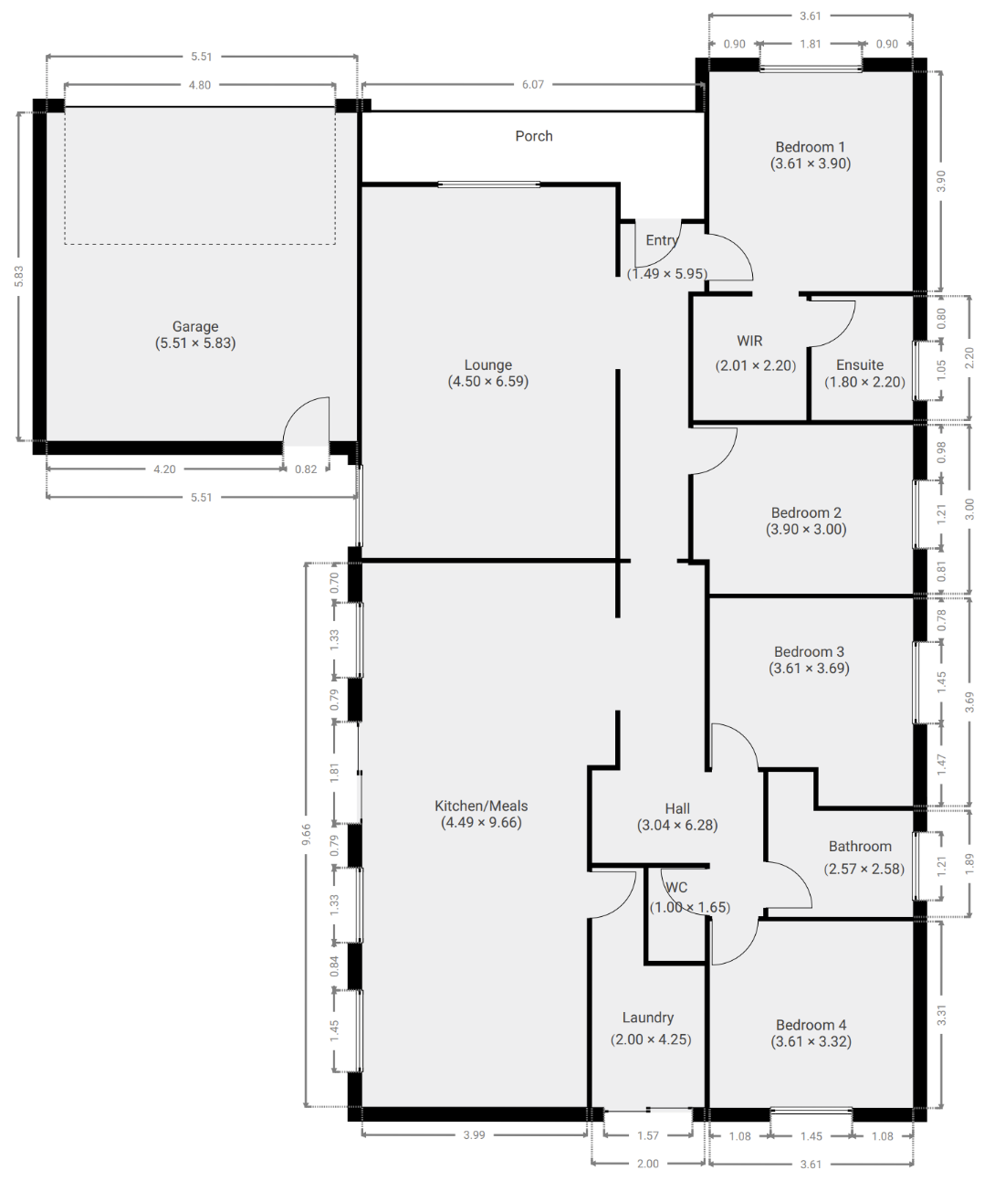 | 69 NatHERS Climate Zones | N/A
401  3-bedroom timber clad | 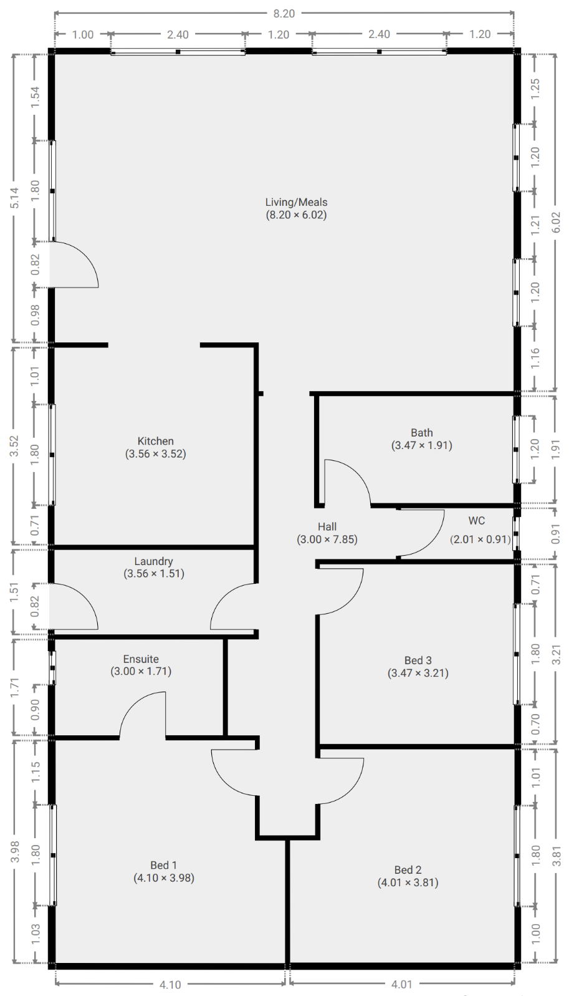 | 69 NatHERS Climate Zones | 11 representative climate zones Table 1  Scenarios at Table 3
501  4-bedroom double-storey | 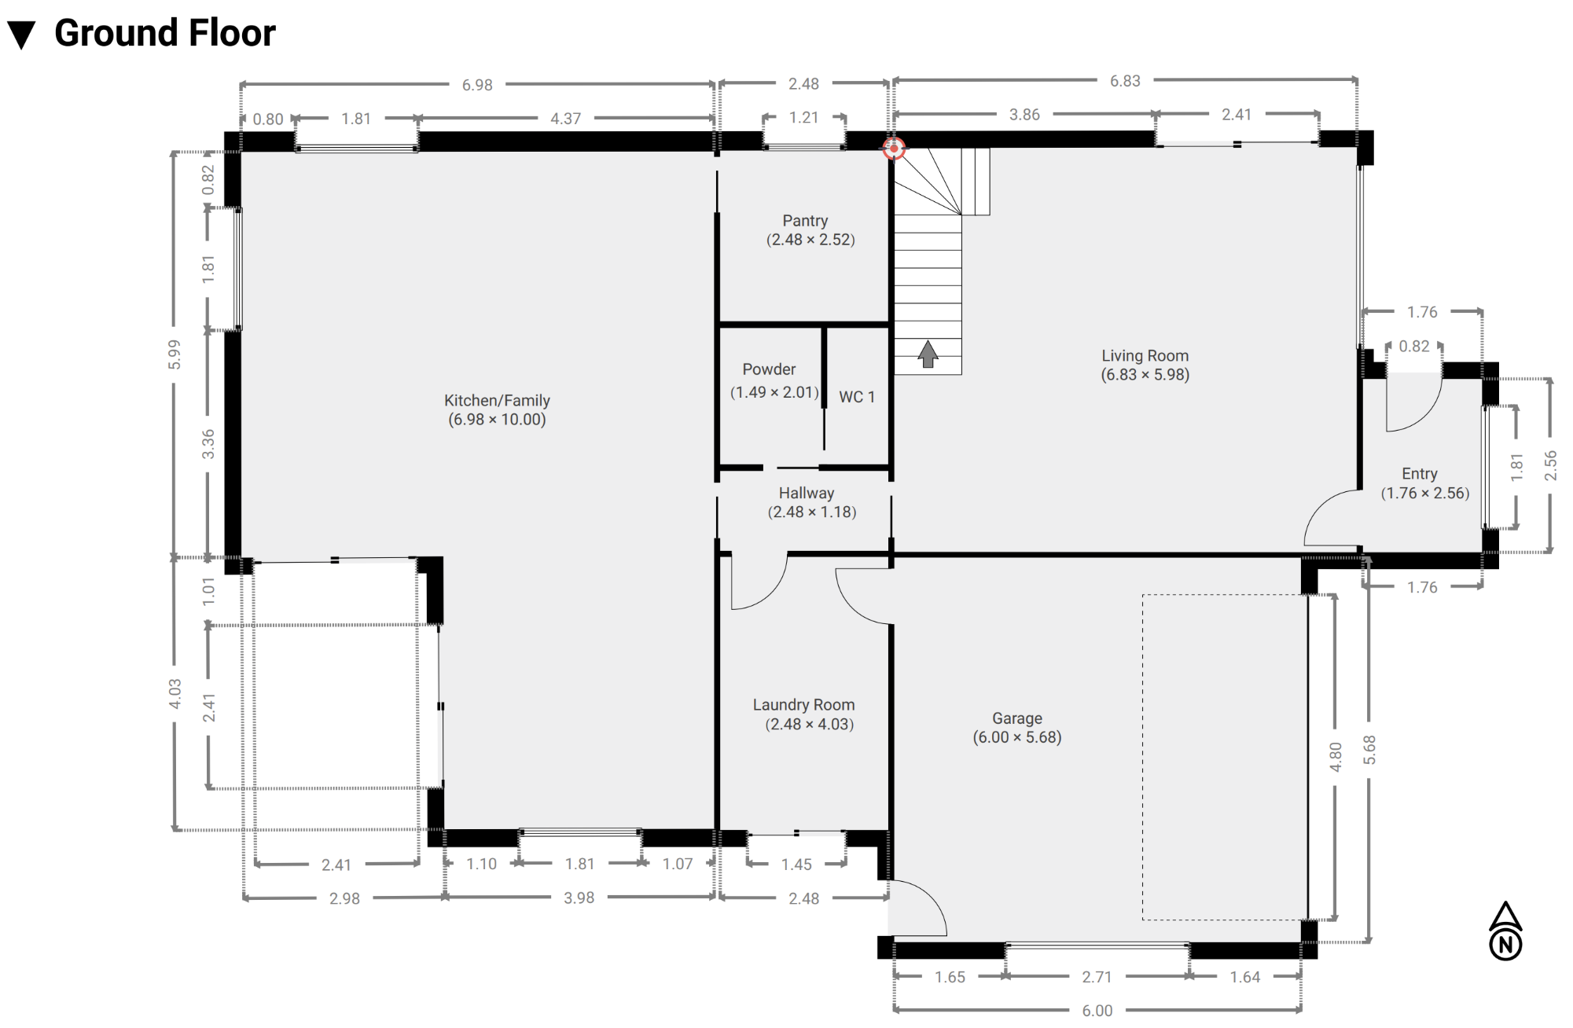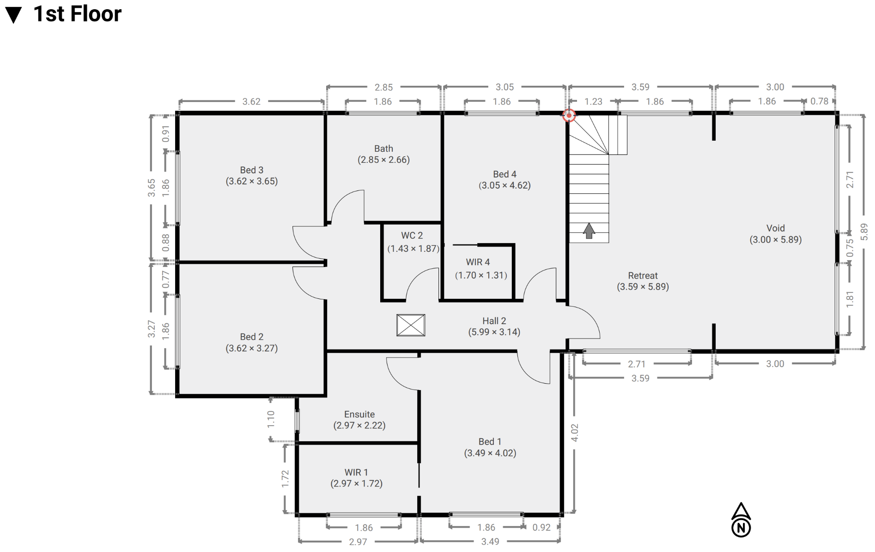 | 69 NatHERS Climate Zones | 11 representative climate zones Table 1  Scenarios at Table 3
611  1-bedroom ground floor apartment | 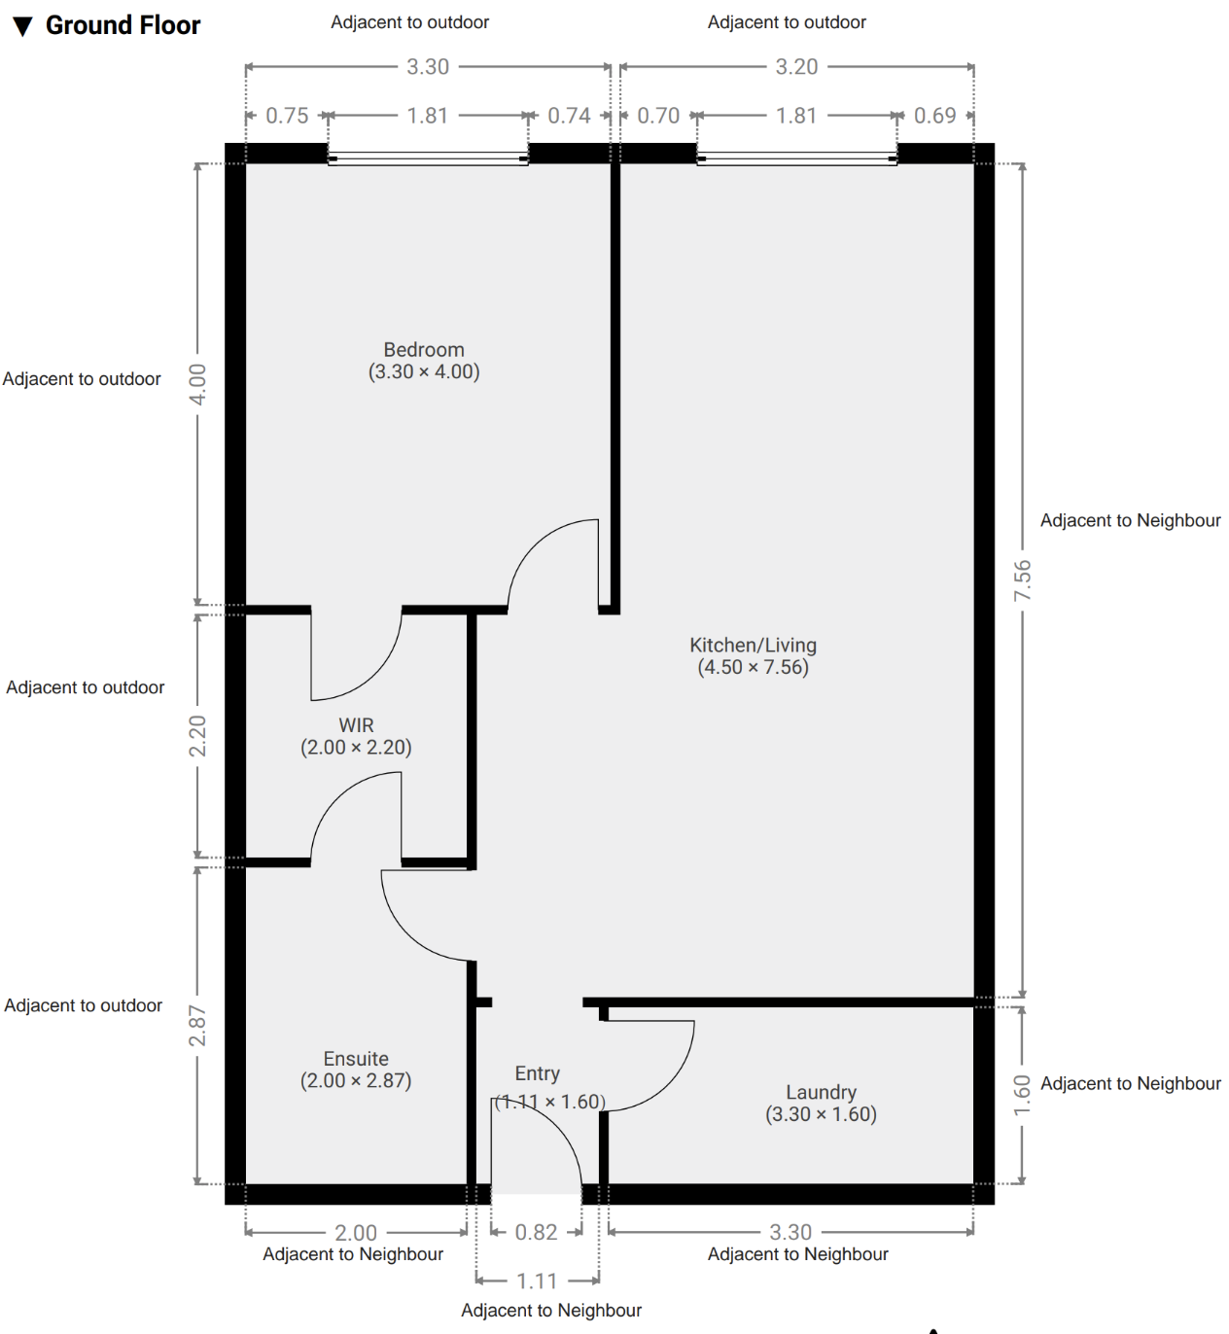 | 69 NatHERS Climate Zones
631  2-bedroom top floor apartment | 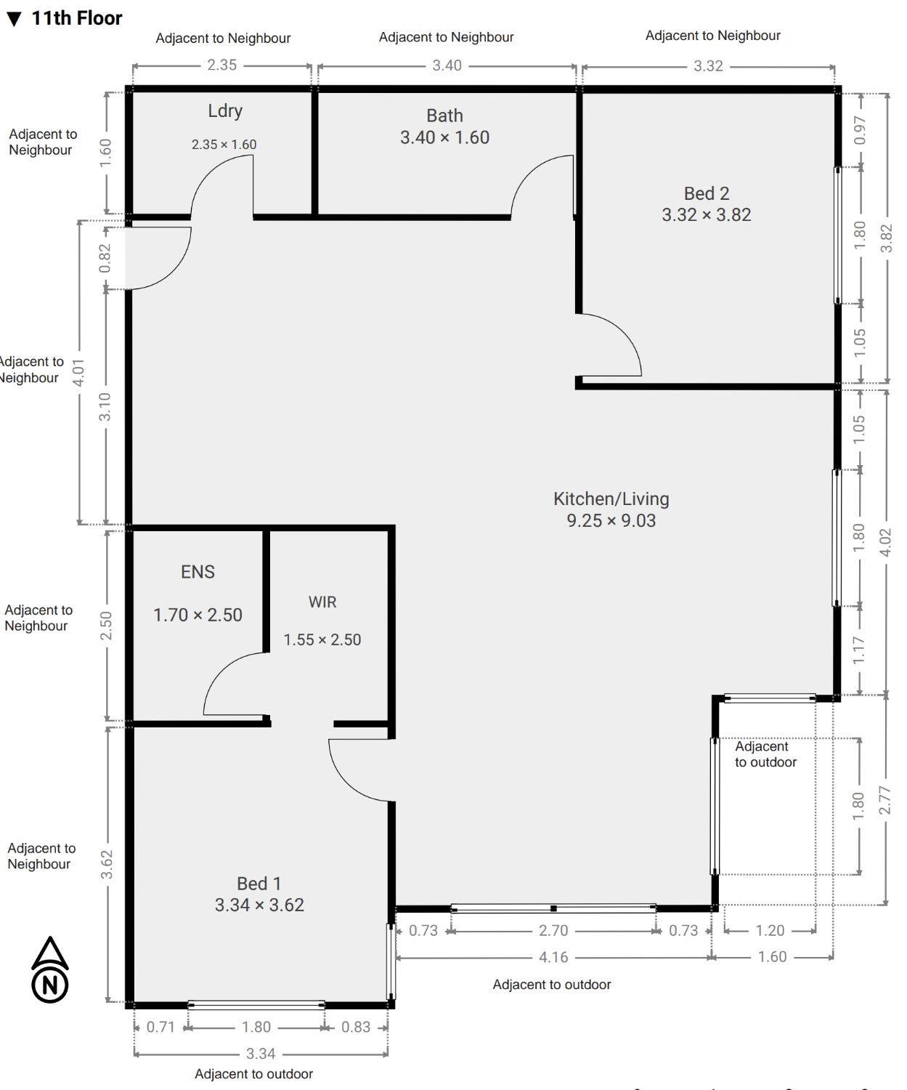 | 69 NatHERS Climate Zones | NA

Table 1: NatHERS reference climate zones
NatHERS climate zone number | NatHERS climate zone name | Postcode | Category
1 | Darwin | 800 | Hot
3 | Longreach | 4730 | Hot
10 | Brisbane | 4000 | Hot
13 | Perth (Breton Bay) | 6043 | Mixed
27 | Mildura | 3500 | Mixed
28 | Richmond (NSW) | 2753 | Mixed
16 | Adelaide | 5000 | Mixed
24 | Canberra | 2600 | Cold
26 | Hobart | 7000 | Cold
60 | Tullamarine | 3043 | Cold
69 | Thredbo | 2625 | Cold

Table 2: Benchmark new homes testing scenarios for appliance and system settings (UNDER REVIEW)
Scenario | Heating and cooling |  |  |  |  |  |  |  |  |  |  |  | Hot Water |  |  | Lighting |  | Solar PV |  |  |  |  |  |  |  |  |  |  |  |  |  |  |  |  |  | Battery |  |  | Pool |  |  | Cooking
Scenario | Primary |  |  |  |  |  | Secondary |  |  |  |  |  |  |  |  |  |  |  |  |  |  | Array 1 |  |  |  | Array 2 |  |  |  | Array 3
Scenario | Heating | Rating | Value | Cooling | Rating | Value | Heating | Rating | Value | Cooling | Rating | Value | Type | STCs | Power density (w/m2) |  | Size (kW) |  | No. of arrays |  | Orien-tation |  | Slope (deg) | (kW) | Orien-tation |  | Slope (deg) | Size | Orien-tation |  | Slope (deg) | Size | Inverter size (kW) |  | Technology |  | Size (kWh) | Size |  | Pump speed | Cooktop |  | Oven
1 | Non ducted reverse cycle | ZERL | 1.5 | Non ducted reverse cycle | ZERL | 1.5 | Nil (default) | n/a Default | 0 | Nil (default) | n/a Default | 0 | Electric storage small | - | 5 |  | 0 |  | 0 |  | 0 |  | 0 | 0 | 0 |  | 0 | 0 | 0 |  | 0 | 0 | 0 |  | None |  | 0 | 0 |  | Single | Electric |  | Electric
2 | Non ducted reverse cycle | ZERL | 3 | Non ducted reverse cycle | ZERL | 3 | Non ducted reverse cycle | ZERL | 2 | Non ducted reverse cycle | ZERL | 2 | Electric storage large | - | 5 |  | 3 |  | 1 |  | 0 |  | 0 | 3 | 0 |  | 0 | 0 | 0 |  | 0 | 0 | 3 |  | None |  | 0 | 50000 |  | Single | Electric |  | Electric
3 | TBD |  |  |  |  |  | TBD |  |  | TBD |  |  | Electric instantaneous | - | 5 |  | 5 |  | 1 |  | 45 |  | 15 | 5 | 0 |  | 15 | 0 | 0 |  | 15 | 0 | 5 |  | None |  | 0 | 50000 |  | Single | Induction |  | Electric
4 | TBD |  |  |  |  |  | TBD |  |  | TBD |  |  | Gas storage 4.0 star | - | 5 |  | 6.5 |  | 1 |  | 315 |  | 22.5 | 6.5 | 0 |  | 22.5 | 0 | 0 |  | 22.5 | 0 | 5 |  | None |  | 0 | 50000 |  | Single | Gas |  | Electric
5 | Ducted reverse cycle | ZERL | 1.5 | Ducted reverse cycle | ZERL | 2.5 | Ducted reverse cycle | ZERL | 1.5 | Ducted reverse cycle | ZERL | 2.5 | Gas storage 5.0 star | - | 5 |  | 10 |  | 1 |  | 0 |  | 22.5 | 10 | 0 |  | 22.5 | 0 | 0 |  | 22.5 | 0 | 8.5 |  | Lithium-Ion |  | 10 | 25000 |  | Dual | Gas |  | Electric
6 | Ducted reverse cycle | ZERL | 3.5 | Ducted reverse cycle | ZERL | 4.5 | Ducted reverse cycle | ZERL | 3.5 | Ducted reverse cycle | ZERL | 1.5 | Gas instantaneous 4.0 star | - | 4 |  | 10 |  | 2 |  | 45 |  | 22.5 | 5 | 315 |  | 22.5 | 5 | 0 |  | 22.5 | 0 | 8.5 |  | Lead acid |  | 10 | 25000 |  | Dual | Gas |  | Electric
7 | TBD |  |  |  |  |  | TBD |  |  | TBD |  |  | Gas instantaneous 5.0 star | - | 4 |  | 10 |  | 3 |  | 0 |  | 22.5 | 4 | 90 |  | 22.5 | 3 | 270 |  | 22.5 | 3 | 8.5 |  | Zinc Bromine |  | 10 | 25000 |  | Dual | Gas |  | Electric
8 | TBD |  |  |  |  |  | TBD |  |  | TBD |  |  | Gas instantaneous 6.0 star | - | 4 |  | 10 |  | 2 |  | 0 |  | 22.5 | 5 | 270 |  | 22.5 | 5 | 0 |  | 22.5 | 0 | 8.5 |  | Lithium-Ion |  | 15 | 75000 |  | Multi | Gas |  | Electric
9 | Gas ducted | Gas Ducted | 4 | Ducted evaporative | n/a | 15 | Gas ducted | Gas Ducted | 4 | Ducted evaporative | n/a | 15 | Gas instantaneous 7.0 star | - | 4 |  | 6.5 |  | 1 |  | 0 |  | 22.5 | 6.5 | 0 |  | 22.5 | 0 | 0 |  | 22.5 | 0 | 5 |  | Lead Acid |  | 15 | 75000 |  | Multi | Gas |  | Electric
10 | Gas ducted | Gas Ducted | 5 | Ducted evaporative |  | 15 | Gas ducted | Gas Ducted | 5 | Ducted evaporative | n/a | 15 | Solar-electric | 17 | 4 |  | 6.5 |  | 1 |  | 0 |  | 22.5 | 6.5 | 0 |  | 22.5 | 0 | 0 |  | 22.5 | 0 | 5 |  | Zinc Bromine |  | 15 | 75000 |  | Multi | Gas |  | Electric
11 | Gas ducted | Gas Ducted | 6 | Ducted evaporative | n/a | 15 | Gas ducted | Gas Ducted | 6 | Ducted evaporative | n/a | 15 | Solar-electric | 27 | 3 |  | 0 |  | 0 |  | 0 |  | 0 | 0 | 0 |  | 0 | 0 | 0 |  | 0 | 0 | 0 |  | None |  | 0 | 0 |  | Single | Gas |  | Electric
12 | Gas space heater | Gas Space | 4 | Evaporative cooler | n/a | 15 | Non ducted reverse cycle | ZERL | 2.5 | Non ducted reverse cycle | ZERL | 3.5 | Solar-electric | 38 | 3 |  | 0 |  | 0 |  | 0 |  | 0 | 0 | 0 |  | 0 | 0 | 0 |  | 0 | 0 | 0 |  | None |  | 0 | 0 |  | Single | Gas |  | Electric
13 | Gas space heater | Gas Space | 4.5 | Evaporative cooler | n/a | 15 | Non ducted reverse cycle | ZERL | 3.5 | Non ducted reverse cycle | ZERL | 4.5 | Solar-gas | 17 | 3 |  | 0 |  | 0 |  | 0 |  | 0 | 0 | 0 |  | 0 | 0 | 0 |  | 0 | 0 | 0 |  | None |  | 0 | 0 |  | Single | Gas |  | Gas
14 | Gas space heater | Gas Space | 5 | Evaporative cooler | n/a | 15 | Nil (default) | n/a Default | 0 | Nil (default) | n/a Default | 0 | Solar-gas | 27 | 3 |  | 0 |  | 0 |  | 0 |  | 0 | 0 | 0 |  | 0 | 0 | 0 |  | 0 | 0 | 0 |  | None |  | 0 | 0 |  | Single | Gas |  | Gas
15 | Wood Heater | n/a | 1 | Evaporative cooler | n/a | 15 | Nil (default) | n/a Default | 0 | Nil (default) | n/a Default | 0 | Solar-gas | 38 | 3 |  | 0 |  | 0 |  | 0 |  | 0 | 0 | 0 |  | 0 | 0 | 0 |  | 0 | 0 | 0 |  | None |  | 0 | 0 |  | Single | Gas |  | Gas
16 | Electric Resistance | n/a | 1 | Nil (default) | n/a Default | 0 | Electric resistance heater | n/a Electric Resistance | 1 | Nil (default) | n/a Default | 0 | Heat-pump | 18 | 5 |  | 0 |  | 0 |  | 0 |  | 0 | 0 | 0 |  | 0 | 0 | 0 |  | 0 | 0 | 0 |  | None |  | 0 | 0 |  | Single | Electric |  | Electric
17 | Nil (default) | n/a Default | 0 | Nil (default) | n/a Default | 0 | Nil (default) | n/a Default | 0 | Nil (default) | n/a Default | 0 | Heat-pump | 27 | 5 |  | 0 |  | 0 |  | 0 |  | 0 | 0 | 0 |  | 0 | 0 | 0 |  | 0 | 0 | 0 |  | None |  | 0 | 0 |  | Single | Induction |  | Electric
18 | TBD |  |  | TBD |  |  | TBD |  |  | TBD |  |  | PV Diverter | Type 1 | 5 |  | 10 |  | 1 |  | 0 |  | 22.5 | 10 | 0 |  | 22.5 | 0 | 0 |  | 22.5 | 0 | 8.5 |  | None |  | 0 | 0 |  | Single | Electric |  | Electric
19 | TBD |  |  | TBD |  |  | TBD |  |  | TBD |  | 2 | PV Diverter | Type 2 | 5 |  | 10 |  | 1 |  | 0 |  | 22.5 | 10 | 0 |  | 22.5 | 0 | 0 |  | 22.5 | 0 | 8.5 |  | None |  | 0 | 0 |  | Single | Induction |  | Electric
20 | Nil (default) | n/a Default | 0 | Nil (default) | n/a Default | 0 | Nil (default) | n/a Default | 0 | Nil (default) | n/a Default | 0 | PV Diverter | Type 3 | 5 |  | 10 |  | 1 |  | 0 |  | 22.5 | 10 | 0 |  | 22.5 | 0 | 0 |  | 22.5 | 0 | 8.5 |  | None |  | 0 | 0 |  | Single | Electric |  | Electric

Table 3: Benchmark existing homes testing scenarios for appliance and system settings
Category | Input | Scenario
Category | Input | 1 | 2 | 3 | 4 | 5 | 6 | 7 | 8 | 9 | 10 | 11 | 12
Primary zone heating (apply to all kitchen/ living, living and daytime zones) | Year | 2019 | 2019 | 2013 | 2013 | 2013 | 2013 | 1999 | 1999 | NA | 2021 | 2019 | Not a tool input
 | Heating appliance | Ducted variable capacity | Split system variable capacity | Split system variable capacity | Split system fixed capacity | Ducted fixed capacity | Split system variable capacity | Ducted fixed capacity | Split system fixed capacity | Open fireplace | Slow combustion | Split system variable capacity | Natural gas Hydronic - panel
 | Efficiency based on | GEMS energy star rating | GEMS energy star rating | GEMS energy star rating | GEMS energy star rating | Small ducted system < 19kW | Split system ≥ 4kW | GEMS energy star rating | Window wall unit | Not a tool input | Year of unit | GEMS energy star rating | NA
 | Rating | 3-Star | 4-Star | 3-Star | 4-Star | Not a tool input | Not a tool input | 1.5-Star | Not a tool input | Not a tool input | Not a tool input | 5-Star | NA
Primary zone cooling (apply to all kitchen/ living, living and daytime zones) | Year | 1999 | 1999 | 1999 | Not a tool input | Not a tool input | 2020 | 2019 | 2019 | 2013 | 2013 | 2013 | 2013
 | Cooling appliance | Ducted fixed capacity | Split system fixed capacity | Split system fixed capacity | Default cooling device | Evaporative cooler | Ducted variable capacity | Ducted variable capacity | Split system variable capacity | Ducted fixed capacity | Ducted fixed capacity | Ducted fixed capacity | Split system variable capacity
 | Efficiency based on | GEMS energy star rating | GEMS energy star rating | window wall unit | Not a tool input | Not a tool input | Small ducted system ≥ 19kW | GEMS energy star rating | GEMS energy star rating | GEMS energy star rating | GEMS energy star rating | GEMS energy star rating | GEMS energy star rating
 | Rating | 3 | 2 | NA | NA | NA | NA | 3 | 3.5 | 1.5 | 3 | 2.5 | 4
Secondary zone heating (apply to all bedroom and nighttime zones) | Year | Not a tool input | Not a tool input | 2019 | 2019 | 2019 | 2019 | Not a tool input | Not a tool input | Not a tool input | 2019 | 2019 | 1999
 | Heating appliance | Default heating | Electric panel heater | Gas ducted - flued (standard flue) (Natural Gas) | Gas ducted - flued (standard flue) (LPG) | Gas space - flued (standard flue) (Natural Gas) | Gas ducted - flued (standard flue) (LPG) | Electric Heat Bank | Electric Floor Slab Heater | Heat pump hydronic - floor slab | Gas ducted - flued (standard flue) (Natural Gas) | Gas space - flued (standard flue) (Natural Gas) | Split system fixed capacity
 | Efficiency based on | Not a tool input | Not a tool input | Industry star rating | Industry star rating | Industry star rating | Industry star rating | Not a tool input | Not a tool input | Not a tool input | Industry star rating | Industry star rating | GEMS energy star rating
 | Rating | Not a tool input | Not a tool input | 4.5-Star | 1 | 2-Star | 3-Star | Not a tool input | Not a tool input | Not a tool input | 2-Star | 4.5-Star | 1-Star
Secondary zone cooling (apply to all bedroom and nighttime zones) | Year | 2019 | 2019 | 2013 | 2013 | 2013 | 2013 | 2020 | 1999 | 1999 | 1999 | Not a tool input | Not a tool input
 | Cooling appliance | Ducted variable capacity | Split system variable capacity | Ducted fixed capacity | Split system fixed capacity | Ducted fixed capacity | Split system variable capacity | Split system variable capacity | Ducted fixed capacity | Split system fixed capacity | Split system fixed capacity | Default cooling device | Evaporative cooler
 | Efficiency based on | GEMS energy star rating | GEMS energy star rating | GEMS energy star rating | GEMS energy star rating | Small ducted system < 19kW | Split system ≥ 4kW | Split system < 4kW | GEMS energy star rating | GEMS energy star rating | unknown | Not a tool input | Not a tool input
 | Rating | 1-Star | 2-Star | 2-Star | 3-Star | Not a tool input | Not a tool input | Not a tool input | 3-Star | 2-Star | Not a tool input | Not a tool input | Not a tool input
Hot Water | Hot water system | Solid fuel | Electric storage small MEPS | Electric storage large MEPS | Electric instantaneous | Gas storage (natural) | Gas instantaneous (natural) | PVD (type 1) | Solar-electric | Solar-gas | Heat-pump | Electric storage large pre-MEPS 1999 | Electric storage very small (MEPS 2005)
Hot Water | Rating | Not a tool input | Not a tool input | Not a tool input | Not a tool input | 2 | 4 | 300L | STC27 | STC27 | STC27 | 5 | NA
Lighting | Lighting power density | 5 | 5 | 5 | 5 | 5 | 5 | 5 | 5 | 5 | 5 | 5 | 5
Lighting | Halogens | As per base file- do not change | As per base file- do not change | As per base file- do not change | As per base file- do not change | As per base file- do not change | As per base file- do not change | As per base file- do not change | As per base file- do not change | As per base file- do not change | As per base file- do not change | As per base file- do not change | As per base file- do not change

Appendix: Accreditation rating accuracy tolerances

The UI must meet the accuracy requirements specified in Table 4 and Table 5.
Table 4: Thermal rating accuracy tolerances
Condition |  | Parameter |  | Specification
 | Condition 1 | ≤ ±3 % |  | Conditioned floor area tolerance.  (The reported floor area is measured up to the inside edge of the dimensioned wall).
AND | Condition 2 | 100% |  | Heating load difference:  ≤ ±10 % or ≤ ±10 MJ/m² p.a.  AND  Cooling load difference:  ≤ ±10 % or ≤ ±10 MJ/m² p.a.
AND | Condition 3a | 95% |  | Heating load difference:  ≤ ±5 % or ≤ ±5 MJ/m² p.a.  AND  Cooling load difference:  ≤ ±5 % or ≤ ±5 MJ/m² p.a.
 | OR
 | Condition 3b | ≥ 95% |  | ≤ ±0.2 stars
AND | Condition 4 | ≤ 75% |  | Limited simulation bias - less than 75% of star ratings shall be greater than the AE (existing homes) results

Table 5: Home energy rating accuracy tolerances
Appliance or system module | Maximum tolerance
Appliance or system module | Condition 1  100% of all simulations | Condition 2  95% of all simulations
Heating electric | 10% or 20 kWh | 5% or 10 kWh
Heating gas | 10% or 20 kWh | 5% or 10 kWh
Heating wood | 10% or 20 kWh | 5% or 10 kWh
Cooling | 10% or 20 kWh | 5% or 10 kWh
Hot water gas | 10% or 20 kWh | 5% or 10 kWh
Hot water electric | 10% or 20 kWh | 5% or 10 kWh
Lighting | 10% or 20 kWh | 5% or 10 kWh
Pool | 10% or 20 kWh | 5% or 10 kWh
Cooking gas | 10% or 20 kWh | 5% or 10 kWh
Cooking electric | 10% or 20 kWh | 5% or 10 kWh
Plug load | 10% or 20 kWh | 5% or 10 kWh
Solar PV generation | 10% or 20 kWh | 5% or 10 kWh
Total electric | 10% or 20 kWh | 5% or 10 kWh
Total gas | 10% or 20 kWh | 5% or 10 kWh
Total wood | 10% or 20 kWh | 5% or 10 kWh
Import electric | 10% or 250 kWh | 5% or 125 kWh
Export electric | 10% or 250 kWh | 5% or 125 kWh
Net electric | 10% or 250 kWh | 5% or 125 kWh
Energy value | 10% or 20 dollars | 5% or 10 dollars
Home energy rating | 5 points | 2 points

Appendix: CSIRO software updates – SOP

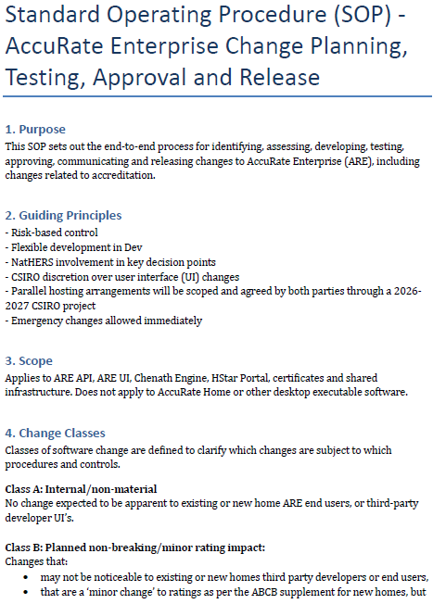
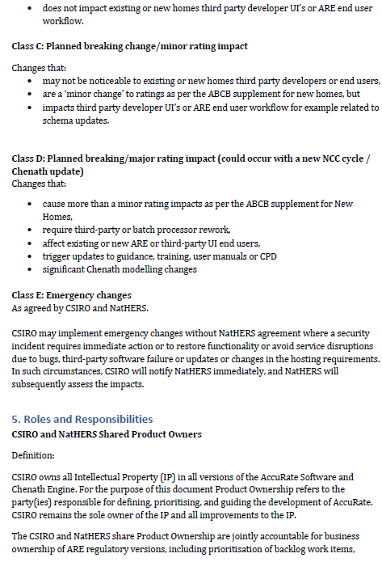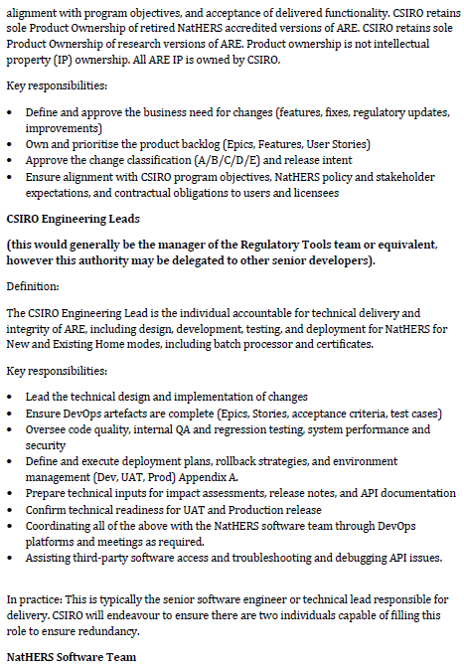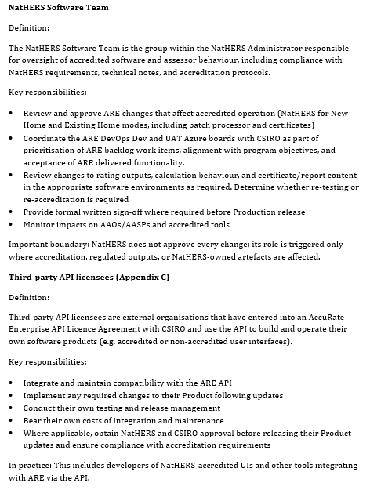
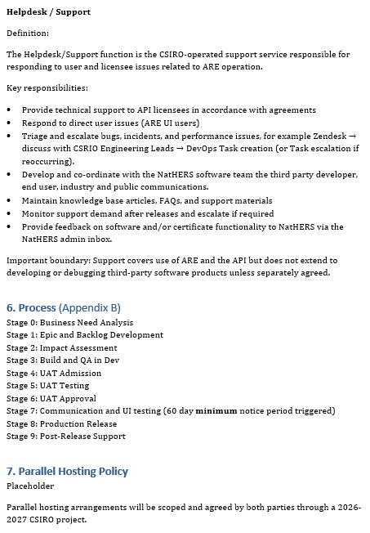
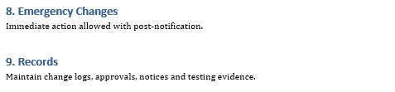

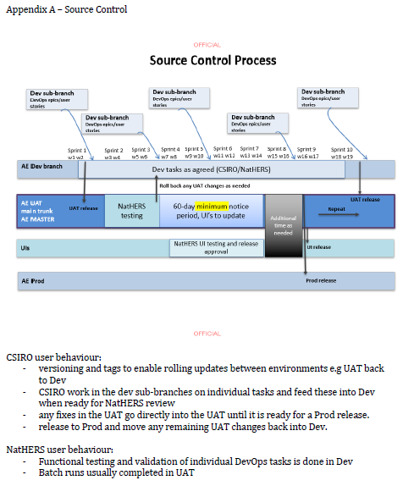

Appendix: General Update form
The General Update Request Form provides a standard way for software providers to submit proposed software changes to the NatHERS Administrator, including their impacts, supporting evidence and implementation arrangements.
Its purpose is to support a consistent, risk-based review of what is changing, how it may affect the software, and what testing or further assessment may be needed before implementation.

 | NatHERS Software - Update Request
- This form should be used for changes proposed to the software.
- Confirm with the NatHERS Administrator what changes are proposed and what must be submitted as part of the update request for review by NatHERS
- Rating outcomes must not exceed the accreditation tolerances compared to the benchmark tool.
- Please return this form to the NatHERS Administrator at uip@nathers.gov.au

Proposal title
Software name and version number |  | Current: …  Proposed: ….
Contact information
Date of submission
Submitted items |  | ☐ Ratings (use template provided by Administrator)  ☐ Beta tool  ☐ Rating files or reference  ☐ Other information
Proposal type |  | ☐ CSIRO update  ☐ Settings/ simplifications  ☐ Supply chain additions/alternatives  ☐ Security patches  ☐ Assessor guidance  ☐ UI design (visual refresh)  ☐ UI design (work flows & layout optimisation  ☐ Bug fix/es
Reason for update
Describe the nature and extent of the problem/s that is/are to be addressed by the change. You may include: information about who is affected and in what way, the risks, etc
Impact of update
Describe the cumulative/combined rating impacts of the update. Outline the testing process or other evidence used to demonstrate the impact.
Proposed implementation
Explain the change and how the change is to be implemented, and the proposed timeline. Include details about any dependencies.
Training resources
Will training resources need updating? Please attach
Communications
How will users be informed? What information will be communicated?
Supporting documentation
Any supporting documentation, including a list of any attachments.
Relationship to legislation
Detail any related legislation if applicable. Will state and territory building administrations be affected by these changes? If you don’t know leave blank.
Recommendation

Appendix: General update review procedures
Updates must remain within the accreditation tolerances. The general update review procedure is the risk-based process which may be used to assess proposed changes to accredited software and identify which evidence and checks are relevant to the change. The steps are:
- Confirm the proposed change with the NatHERS team. The software provider shall discuss the change with the NatHERS team and confirm what needs to be submitted. The software provider shall identify the requirements and components affected by the update and assess its individual and cumulative effects on rating accuracy, compatibility, data exchange, assessment workflows, security, privacy, documentation and existing assessment records.
- Submit an Update Request form. The software provider shall describe the proposed change, affected requirements and components, implementation arrangements, testing and communications, and assess its individual and cumulative impacts on software functionality, rating accuracy, data exchange, workflows, security, privacy, documentation and existing assessment records.
- Provide supporting evidence. Depending on the change, this may include access to the updated or beta software, test rating files, rating results, details of supply chain services, or revised guidance material.
- Determine the review scope. The NatHERS team will apply a risk-based approach to determine the checks required for the proposed update. Depending on the nature and risk of the change, these may include rating accuracy, API schema validation, Technical Note compliance, security, access controls, assessor impacts, terms and conditions, and branding. Table 6 provides an indicative guide to the review scope.
- Resolve findings and undertake retesting: The NatHERS team shall record identified non-compliances, clarification requests and required corrective actions. The software provider shall provide corrections, further evidence or retesting as requested. Outstanding matters shall be resolved or explicitly addressed in the update decision.
- Decision and confirm release: The software provider shall confirm the release version, implementation date, dependencies, user communications, revised training or guidance, and arrangements for existing projects and assessment records. Release shall be consistent with the update decision and applicable Protocol requirements.
Table 6: General change indicative checks
Change / update type | Evidence to be submitted by software provider for review by NatHERS | Indicative checks
Change / update type |  | Rating accuracy tolerances | API schema validation | Tech Note compliance | Security | Access  (e.g. MFA) | Assessor impacts | Terms and Conditions | Branding / trademark guidelines
CSIRO updates | Software tool & test rating files | Check | TBD | — | — | — | Check | — | —
Settings (simplifications) | Software tool & test rating files | Check | Check | Check | TBD | — | Check | — | --
Supply chain: additional or alternative vendors | Software tool &  Details of software or service | Check | — | Check | TBD | — | Check | — | --
Security patches | Details of update | — | — | — | Check | TBD | — | TBD | --
Bug fixes | Software tool | TBD | TBD | — | TBD | TBD | TBD | — | —
Help/training (in-built into UI) | Software tool | — | — | Check | — | — | Check | — | TBD
Help/training (external to UI) | Help / training material | — | — | Check | — | — | Check | TBD
UI: visual / aesthetic refresh | Software tool | — | — | TBD | — | — | TBD | — | —
UI: navigation, user flow & layout optimisation | Software tool | — | TBD | TBD | — | — | TBD | — | —
Customised reports | Software tool | — | — | TBD | — | — | TBD | — | TBD

UI: user interface
TBD: to be determined on a case-by-case basis

Appendix: Minimum software training requirements for new and existing homes

Purpose
The software provider must develop, maintain and make available appropriate training, user guidance and support resources to enable assessors and data collectors, where applicable, competently, consistently and accurately use the software to undertake NatHERS assessments.
Software training and guidance should focus on the software functions required to collect, enter, review and verify assessment information, and to complete a compliant NatHERS assessment. Training should clearly distinguish between functions performed by data collectors and functions that must be completed, reviewed or approved by an accredited assessor.

Training scope and resource requirements
Training resources should be fit for purpose to train trainees in their first software tool or an additional software tool, as required.
Training resources should be suitable for the intended user and workflow, including accredited assessors, data collectors and workflows where assessment information passes between different users for collection, review, verification and approval.
Training resources should explain how software-specific functions, including scanning technologies, imported data, optical character recognition, automated data capture, AI-assisted features and third-party integrations, where available, should be used, reviewed and verified before the information is relied upon in a NatHERS assessment. They should also explain the source, traceability and known limitations of information generated or processed by these functions.
The software provider must maintain and update training resources to reflect relevant software updates, new or changed functionality, applicable Technical Note requirements and the introduction or modification of data capture, automated, AI-assisted or third-party functions.
Detailed requirements for competency assessment, trainer endorsement, supervised practice and accreditation remain subject to the relevant NatHERS training and accreditation policy framework.
Training, user guidance and support materials must be designed to ensure assessors understand how the software tool is to be used to complete the following aspects of an assessment:
- Data collection
  - Scanning equipment (if applicable)
    - Correct scanning techniques and room capture
    - Equipment maintenance and compliance
    - Checking the completeness and accuracy of captured information
  - Manual data entry
  - Importing plans, models and supporting information
  - Reviewing and validating imported or automatically generated data, including:
    - Imported, scanned or optical character recognition-derived information
    - Identifying and correcting data capture or import errors
    - Understanding the software-specific limitations of automated data capture tools
    - Verifying information before it is relied upon in an assessment

- Start a new project
  - Project settings, including:
    - Climate zone
    - Terrain and exposure
    - Orientation
    - Year of construction approval (where applicable)
  - Declarations and consent
  - Applying assumptions and defaults
  - Assigning and managing relevant user roles, permissions and workflow stages, where supported by the software

- Model specific thermal features including:
  - Building geometry and zoning, including:
    - Assembling floorplans
    - Zoning and zone adjacencies
    - Uninhabited zones (for example, subfloor spaces, attics and roof spaces)
    - Bathrooms, laundries, garages and common areas
    - Horizontal openings between levels
    - Double-height voids, split-level dwellings and other complex geometry
  - Floors, walls, ceilings and roofs, including:
    - Adjacencies to another zone, ground, garages and common areas
    - Insulation and construction details
    - Colour and absorptance settings
  - Thermal bridging and thermal breaks (where applicable)
  - Airtightness, ventilation and ceiling features including:
    - Ceiling penetrations
    - Ceiling fans
    - Exhaust fans, flues and vents
    - Window and door sealing
    - Airtightness inputs and other leakage pathways
  - Windows, glazing and doors, including:
    - Default and custom windows
    - Skylights and roof windows
    - Window coverings
    - Internal and external doors
  - Shading, including:
    - Horizontal and vertical shading
    - Wing walls (if applicable) and external screens
    - Neighbouring buildings and surrounding features
    - Multiple shading schemes

- Model appliances and systems
  - Heating and cooling systems, including multiple zones and multiple systems
  - Hot water systems
  - Cooking appliances
  - Lighting
  - Pools and spas
  - On-site renewable energy systems, including multiple PV arrays and inverter sizing
  - On-site energy storage systems, including battery type and capacity

- Evidence, quality assurance and troubleshooting
  - Correctly capture, store and attach evidence to the assessment, including:
    - Linking evidence to the relevant assessment input, feature, appliance or zone
    - Maintaining traceability between source information, evidence and software inputs
    - Reviewing imported, scanned, optical character recognition-derived, automated or AI-assisted outputs
    - Recording assumptions, defaults, substitutions and corrections
  - Quality assurance and troubleshooting processes
  - Perform basic troubleshooting before contacting support
  - Undertake a self-review to confirm:
    - Accuracy and completeness
    - Compliance with the applicable Technical Note
    - Consistency between source evidence, imported or captured data and assessment inputs
    - Correct application of assumptions, defaults and substitutions
    - Completion of any required data collector and accredited assessor review steps
  - Access help, support and guidance resources
  - Report suspected software defects, data errors, rating inaccuracies, security concerns or other significant issues through the software provider’s support and reporting channels.

- Finalising a project
  - Review assessment results and assumptions
  - Complete final quality checks
  - Produce rating summaries, reports and NatHERS Certificate(s)
  - Save, export and retain project records and supporting evidence

Nathers software standardisation document for existing homes
Where a value is not displayed in the software tool, it may be inferred by applying alternative metrics
This update does not affect the UI no change log entry is required

